**Lake and Reservoir Management**

**ISSN: (Print) (Online) Journal homepage:** [**https://www.tandfonline.com/loi/ulrm20**](https://www.tandfonline.com/loi/ulrm20)



**Paleolimnological Assessment of Six Lakes on the Kissimmee Chain, with Implications for Restoration of the Kissimmee–Okeechobee–Everglades system, Florida, USA**

**Thomas J. Whitmore , Melanie A. Riedinger-Whitmore , Zachary E. Reed , Jason H. Curtis , Handong Yang , Deveny E. Evans , Nicholas R. Cropper , Karla S. Alvarado , Francesca M. Lauterman , Austyn Scott , Christine R. Leonard & Daniel L. Franklin**

**To cite this article:** Thomas J. Whitmore , Melanie A. Riedinger-Whitmore , Zachary E. Reed ,Jason H. Curtis , Handong Yang , Deveny E. Evans , Nicholas R. Cropper , Karla S. Alvarado , Francesca M. Lauterman , Austyn Scott , Christine R. Leonard & Daniel L. Franklin (2020):

Paleolimnological Assessment of Six Lakes on the Kissimmee Chain, with Implications for Restoration of the Kissimmee–Okeechobee–Everglades system, Florida, USA, Lake and Reservoir Management, DOI: [10.1080/10402381.2020.1785064](https://www.tandfonline.com/action/showCitFormats?doi=10.1080/10402381.2020.1785064)

**To link to this article:** <https://doi.org/10.1080/10402381.2020.1785064>



[View supplementary material](https://www.tandfonline.com/doi/suppl/10.1080/10402381.2020.1785064) 



[Submit your article to this journal](https://www.tandfonline.com/action/authorSubmission?journalCode=ulrm20&show=instructions) 



[View related articles](https://www.tandfonline.com/doi/mlt/10.1080/10402381.2020.1785064) 



Published online: 21 Jul 2020.



Article views: 34



[View Crossmark data](http://crossmark.crossref.org/dialog/?doi=10.1080/10402381.2020.1785064&domain=pdf&date_stamp=2020-07-21)



Full Terms & Conditions of access and use can be found at

<https://www.tandfonline.com/action/journalInformation?journalCode=ulrm20>

LAKE AND RESERVOIR MANAGEMENT

<https://doi.org/10.1080/10402381.2020.1785064>



Paleolimnological Assessment of Six Lakes on the Kissimmee Chain, with Implications for Restoration of the Kissimmee–Okeechobee–Everglades system, Florida, USA

Thomas J. Whitmorea, Melanie A. Riedinger-Whitmorea, Zachary E. Reeda, Jason H. Curtisb,

Handong Yangc, Deveny E. Evansa, Nicholas R. Croppera, Karla S. Alvaradoa, Francesca M. Lautermana, Austyn Scotta, Christine R. Leonarda and Daniel L. Franklina

aDepartment of Integrative Biology, University of South Florida, 140 7th Avenue S., St. Petersburg, FL, 33701, USA; bDepartment of Geological Sciences, University of Florida, 241 Williamson Hall, Gainesville, FL, 32611, USA; cEnvironmental Change Research Centre, University College London, Gower Street, London, WC1E 6BT, UK

ABSTRACT

Whitmore TJ, Riedinger-Whitmore MA, Reed, ZE, Curtis, JH, Yang H, Evans DE, Cropper NR, Alvarado KS, Lauterman FM, Scott A, Leonard DE, Franklin DL. 2020. Paleolimnological assessment of six lakes on the Kissimmee Chain, with implications for restoration of the Kissimmee–Okeechobee–Everglades systerm, Florida, USA. Lake Resrv Manage. XX:XX–XX.

The Kissimmee Basin in south central Florida contains a large, freshwater network that includes the Kissimmee River and nearly 2 dozen lakes that are headwaters of the Florida Everglades. Management of these lakes is an important part of Everglades restoration. We report a paleolimnological investigation of 6 lakes in the Upper Kissimmee Basin. Engineering activities connected the lakes and permanently altered hydrology in the 19th and 20th centuries. The lakes were naturally meso-eutrophic, but changes in lake levels and nutrient loading contributed to different degrees of eutrophication. Cyanobacteria were pre-sent historically at low levels in Lakes East Tohopekaliga, Cypress, and Tohopekaliga, but increased during the 20th century. Lake Jackson lacked cyanobacteria until recently, but Lakes Kissimmee and Marian have had high levels of cyanobacteria since predisturbance times. Profound changes in the lakes occurred after engineering activities eliminated natural large fluctuations in water levels that periodically dried large portions of the basins. Salt-tol-erant biological indicators previously alternated with freshwater organisms. Large water-level fluctuations moderated aquatic-plant standing crops and reduced organic matter accu-mulation. Lakes Kissimmee and Marian showed greatest evidence of former associated wet-lands, but lacked large variations in water levels. We recommend disconnecting these lakes from each other and from the Kissimmee River to reestablish large, natural fluctuations in water levels that were part of healthy ecosystem function. Former wetlands should be restored to slow the downstream cascade of nutrients to Lake Okeechobee and the Everglades. This study demonstrates that paleolimnology is useful for assessing hydrological changes that potentially affect lake restoration efforts.

KEYWORDS

Aquatic plants; diatoms; Florida; Kissimmee Chain of Lakes; paleolimnology; paleohydrology; stable isotopes

The Kissimmee Chain of Lakes is a series of shal-low, connected warm-temperate lakes in central Florida. Lakes on the chain are headwaters of the Kissimmee–Okeechobee–Everglades system, which extends from Orange County southward through Lake Okeechobee to the tip of the Florida Everglades, where discharge from the Everglades affects nearshore coral reefs. The lakes are situated in the 6164 km2 Kissimmee Basin, which

contains the Kissimmee River, as well as associated streams and wetlands. Historically, the lakes were surrounded by freshwater marshes, pine flatwoods, and wet prairies that were connected by broad, shallow wetlands and creeks (South Florida Water Management District 2019). Water levels fluctu-ated seasonally, which facilitated the connection of upper to lower lakes through an extensive marsh complex (US Army Corps of Engineers 1996).

CONTACT Thomas J. Whitmore  whitmore@usf.edu



Supplemental data for this article is available online at <https://doi.org/10.1080/10402381.2020.1785064>.

2020 North American Lake Management Society

2  T. J. WHITMORE ET AL.

A major effort to connect the lakes to the Kissimmee River and to Lake Okeechobee through canal construction began by the early 1880s. Canals were constructed to lower water levels and drain the northern Everglades region, to lessen flood impacts, to expand areas available for agricul-ture and ranching, and to reduce water flow and flooding in the lower Everglades. Water levels dropped by 1.8 m in lakes throughout the Upper Kissimmee Basin (US Army Corps of Engineers 1996), and connections between lakes and associated wetlands were severed (Atlantic and Gulf Coast Canal and Okeechobee Land Company 1885). Throughout the 1900s, wetland areas were drained for agriculture. Marshes adjacent to lakes were reduced to narrow littoral zones, which affected plant and animal communities (US Army Corps of Engineers 1996). Modern areas of the lakes are sub-stantially smaller than their historic sizes because of drainage activities (Osceola County Community Development Department 2015). Upstream urban-ization and agriculture led to increases in nutrient loading in some lakes. Point-source inputs had pro-nounced effects on Lake Tohopekaliga, which in turn affected Lake Cypress (Huber et al. 1982, Dierberg et al. 1988, James et al. 1994, Williams 2001). Subsequent channelization of the Kissimmee River by the Army Corps of Engineers in the 1960s had adverse ecological and water-quality consequen-ces for Upper Basin lakes. Current management and nutrient mitigation of lakes on the Kissimmee Chain are important parts of the restoration initia-tive for the Florida Everglades, the largest Ramsar Convention wetland complex in the United States.

Paleolimnology has a well-established role in ecosystem management because it provides long-term environmental information that is often undocumented (Smol 1992, Brenner et al. 1993, Battarbee and Bennion 2011, Bennion et al. 2011, Davidson and Jeppesen 2013, Larocque-Tobler 2016). Predisturbance conditions in lakes of the Upper Kissimmee Basin are unknown, which has posed a challenge for establishment of appropriate restoration targets for the lakes. This study used paleolimnological methods to analyze a total of 18 sediment cores from Lakes Kissimmee, Cypress, Marian, Jackson, Tohopekaliga, and East Tohopekaliga on the Kissimmee Chain (Figure 1). The objective was to describe water quality and

ecological conditions, including aquatic plants, algae, and cyanobacteria, during reference periods that represented low human impact on the lakes during the early 1800s, and to document subse-quent changes. Additionally, the purposes were to assess changes in nutrient deposition rates, and to determine whether associated wetlands were pre-sent that might have contributed significant amounts of colored dissolved organic carbon to the lakes and attenuated algal production. Our intention was to assist the Osceola County Public Works Department and the Florida Department of Environmental Protection (Florida DEP) in defin-ing appropriate restoration goals for the lakes.

Study sites

Lakes on the Kissimmee Chain are managed by the South Florida Water Management District, the US Army Corps of Engineers, the Florida Fish and Wildlife Conservation Commission, the Osceola County Public Works Department, the Florida DEP, and the US Fish and Wildlife Service. Water quality is highly variable, but recently measured values are shown in Table 1. All lakes have high dissolved color values, and therefore are subject to target chlorophyll a values of 20 mg/L (Florida DEP 2013). Lakes Cypress, Jackson, Kissimmee, and Marian are considered impaired because limnetic chlorophyll a values exceed this standard, whereas East Tohopekaliga and Tohopekaliga are not impaired (Osceola County Community Development Department 2015). Because of their better water quality, East Tohopekaliga and Tohopekaliga are designated Class III lakes that are protected for fish consump-tion, recreation, and wildlife. Tohopekaliga, how-ever, demonstrated extreme hypereutrophic conditions in recent decades (Huber et al. 1982). Lakes Tohopekaliga and Cypress require manage-ment of invasive Hydrilla. Lake Cypress is impaired in terms of total phosphorus and total nitrogen concentrations, as well as for chlorophyll a. East Lake Tohopekaliga does not require man-agement to control Hydrilla, but it has extensive vegetation that creates problematic floating tus-socks. Although Lake Jackson is impaired, it is nearly surrounded by the Three Lakes Wildlife Management Area and by private agricultural

LAKE AND RESERVOIR MANAGEMENT  3

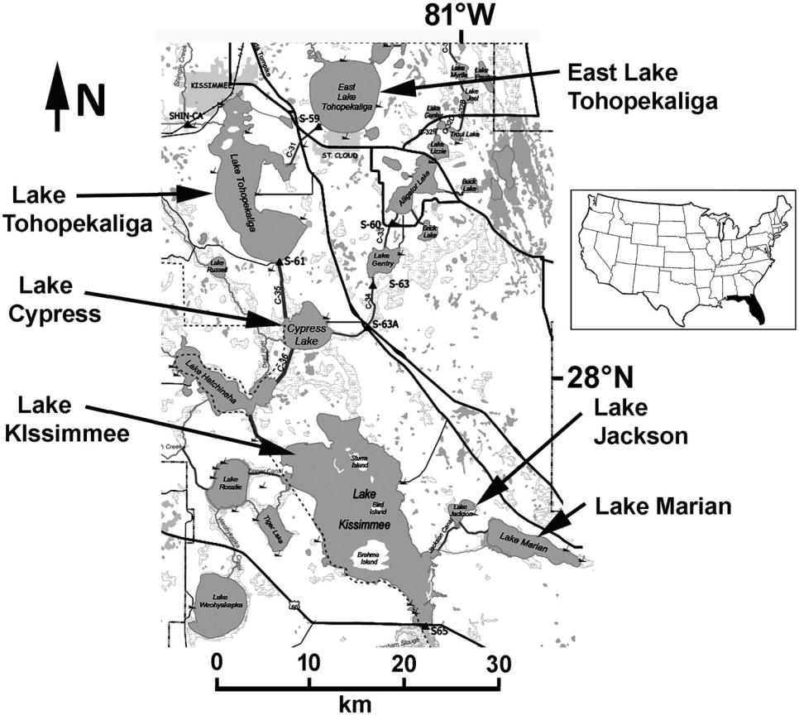

Figure 1. Location of the 6 study lakes in the Upper Kissimmee Basin. Modified from a map prepared by Kissimmee Division, Ecosystem Restoration Department, South Florida Water Management District (2005).

Table 1. Coring locations and modern mean water quality for study lakes.

|  |  |  |  |  |  |
| --- | --- | --- | --- | --- | --- |
|  |  | Coring location |  |  |  |
| Lake | Latitude | Longitude | | Mean Chl-a (mg/L) | Mean TP (mg/L) |
| Cypress | 28 04’09.8”N | 081 18’34.9”W | | 32.1 | 83 |
| East Tohopekaliga | 28 17’59.9”N | 081 16’13.6”W | | 3.9 (2015–2017) | 20.3 |
| Jackson | 27 54’53.2”N | 081 09’32.8”W | | 29.8 | 127 |
| Kissimmee | 27 53’42.6”N | 081 17’38.7”W | | 19.9 | 64 |
| Marian | 27 53’00.1”N | 081 06’56.5”W | | 54.5 | 155 |
| Tohopekaliga | 28 11’39.1”N | 081 24’3.4”W | | 21.9 (2015–2018) | 39.2 |

Water quality averages were obtained from the Florida Department of Environmental Protection for 2000–2006 ( ) for Lakes Cypress, Jackson, Kissimmee, and Marian.

Water quality averages for Lakes East Tohopekaliga and Tohopekaliga were obtained from the Polk County Water Atlas (2019) for 2015–2019, unless otherwise indicated.

Chlorophyll a concentrations are uncorrected for pheophytin for data obtained from the Polk County Water Atlas.

lands. Lakes Marian and Kissimmee sustain the highest limnetic total P and chlorophyll a concen-trations (Table 1). Lake Kissimmee was placed on the federal list of impaired waters in 2006, and it is subject to management for invasive Hydrilla.

Historical influences on the lakes

In 1884, Lake Topekaliga and other lakes along the Kissimmee River were described as having

“pure, clear water” (Atlantic and Gulf Coast Canal and Okeechobee Land Company 1885). Prairie lands and hardwood forests were situated along the lake shores, with large tracts of cypress (Taxodium) in intermittent swamps. Sawgrass (Cladium jamaicense), organic-rich sediments, and aquatic plants were reported in wetlands near East Lake Tohopekaliga. A continuous marsh extended from Lake Cypress to the north bay of Lake Kissimmee.

4  T. J. WHITMORE ET AL.

Cattle ranches were well established in the Kissimmee Basin by the 1860s (Otto 1985). More extensive impacts began with settlement after the Civil War (c. 1865), when the region was further developed for agriculture and cattle ranching. Kissimmee City was founded on the northern shore of Lake Tohopekalgia in 1883, and the city of St. Cloud was founded in 1909 on the south-ern shore of East Lake Tohopekaliga.

Canal construction to join Upper Basin lakes to the Kissimmee River began in the 1880s. The St. Cloud Canal was dug through marshes to drain East Lake Tohopekaliga into Lake Tohopekaliga. Prior to 1884, East Lake Tohopekaliga was sur-rounded by cypress swamps and marshes that were left stranded above water levels when the lake was lowered, and logging took place on the shores (Atlantic and Gulf Coast Canal and Okeechobee Land Company 1885). East Lake Tohopekaliga fell 1.1 m in 30 d from the drainage. Sugar-cane agriculture was established in drained areas of East Lake Tohopekaliga by 1883. On the western and southern shores of Lake Tohopekaliga, dredging of wetlands and logging occurred in 1883 and 1884 (Atlantic and Gulf Coast Canal and Okeechobee Land Company 1885). Lake Tohopekaliga dropped 0.8 m from drainage, and lakes south of it had lowered water levels. The water level of Lake Okeechobee fell 0.45 m in 1 year.

Population increases occurred after World War

1. in the cities of Kissimmee and St. Cloud. Point-source discharges into Lake Tohopekaliga began in the 1950s (Williams 2001). By 1969, 4 wastewater treatment plants discharged 82.5 met-ric tons of phosphorus and 140 metric tons of nitrogen per year into Lake Tohopekaliga and its tributaries. Water-quality deterioration was evi-dent by 1969. By 1982, limnetic total P averaged 322 lg/L and chlorophyll a averaged 71 lg/L in Lake Tohopekalika (Huber et al. 1982), and nutrients affected lakes that were downstream. In 1988, wastewater discharge into the lake was discontinued.

Massive flooding in 1947 after a hurricane prompted the Army Corps of Engineers to deepen and straighten the Kissimmee River to implement flood-control measures (South Florida Water Management District 2014). In the 1960s,

the river was extensively channelized, which had serious consequences in terms of shortened water-residence times, higher nutrient concentra-tions, and ecological impacts on fish and wildlife in Upper Basin lakes and in Lake Okeechobee. In 1999, the South Florida Water Management District and the US Army Corps of Engineers began the Kissimmee River Restoration Project, which is scheduled to restore 71 km of the nat-ural meandering system by 2020.

Recent water-level manipulation for sediment removal

Florida Fish and Wildlife Conservation Commission has lowered water levels and dewa-tered sediments in several of our study lakes to remove invasive plants and sediment by burning and scraping operations in recent years. Water lev-els in Lake Tohopekaliga were drawn down 1.8 m in 1971, 1979, 1987, and 2004, and scraping occurred in 1987 and 2004. During the 2004 oper-ation, approximately 1350 ha of lake bottom was exposed, and 6.04 million m3 of organic material was removed (Lawrence K, Osceola County Public Works Department, March 2016, pers. comm.). In 1995, Lake Kissimmee was drained to half the size of its normal area for scraping and burning. Because Lake Cypress is controlled by the structure in Lake Kissimmee, its water level also fell. In 2004, East Lake Tohopekaliga was drawn down approxi-mately 1.8 m, and 95% of the littoral zone was scraped. Drawdowns and sediment removal con-tinue as a management practice in lakes of the Kissimmee Chain.

Materials and methods

Field methods and core collection

We conducted a systematic spatial survey of sedi-ment distribution (Whitmore et al. 1996) in Lakes Cypress, East Tohopekaliga, Kissimmee, Jackson, Marian, and Tohopekaliga to identify optimal coring sites. Water depth at each site was measured by lowering a weighted, metered steel cable to the sediment/water interface. Total depth to hard, sandy sediments was measured at each site by inserting magnesium/zirconium rods into the sediment and subtracting the water depth to

estimate soft-sediment thickness. Sediment cores of 1 m in length were recovered with a 1.83-m-long, 7-cm diameter piston corer (Fisher et al. 1992), and backup cores for pollen and macrofos-sil analyses were taken at the same stations using a 4-cm diameter, 1.83-m long cellulose acetate butyrate piston corer.

Cores were sectioned in the field at 5-cm inter-vals to 20 cm depth, then at 3-cm or 4-cm inter-vals to the base of the cores. Samples were stored in Nalgene plastic cups in the dark on ice until they were refrigerated in the laboratory. Diatom samples were collected in the field at the top of each sectioned interval and were preserved with alcohol.

Lead and cesium dating and core chronologies

210Pb dating of all sediment cores was performed at University College London by gamma spec-trometry using an ORTEC HPGe GWL series well-type coaxial low-background intrinsic ger-manium detector (Appleby et al. 1986, Schelske et al. 1994). Unsupported 210Pb activity was cal-

culated by subtracting 226Ra, as estimated from 214Pb, from the total 210Pb activity. 210Pb was

determined via its gamma emissions at 46.5 keV, and 226Ra by the 295 keV and 352 keV gamma

rays emitted by its daughter isotope 214Pb. 137Cs and 241Am, which are artificial radionuclides from weapons testing, were measured by their emissions at 662 kev and 59.5 kev to provide absolute time markers for c. 1963 (Appleby et al. 1986). Corrections were made for the effect of self-absorption of low-energy gamma rays within the sample (Appleby et al. 1992). For Lake Marian core 31_III_2018_MAR_328, radioiso-topic analyses stopped just short of 210Pb sup-ported levels, so excess 210Pb activity was extrapolated by linear regression for 2 samples. Sediment age/depth relationships were calculated using the constant rate of supply model (Appleby and Oldfield 1983), with occasional age adjust-ments based on the location of 137Cs peaks.

Diatom analyses

Diatom samples were digested in the laboratory with 35% H2O2 and K2Cr2O7 according to Van

LAKE AND RESERVOIR MANAGEMENT  5

der Werff (1953), and slides were prepared with Naphrax mounting medium. Approximately 500 valves were counted and identified at each level at 1500 magnification using compound micros-copy. Diatoms were identified using standard flo-ras (Patrick and Reimer 1966–1975, Krammer and Lange-Bertalot 1986–1991) and taxonomic websites (Diatoms of North America 2020). Zonation of diatom assemblages in sediment cores was determined by constrained incremental sum of squares (CONISS) hierarchical agglomera-tive cluster analysis using the statistical program R and the rioja package (Juggins 2012). The number of significant zones in each cluster ana-lysis was determined with a broken-stick model (Bennett 1996) using the rioja package.

Historic water quality inferences were obtained with 2 diatom-based inference models. The mod-els were constructed with a calibration set of 75 Florida lakes that we utilized in past studies (Riedinger-Whitmore et al. 2005, Kenney et al. 2014, Whitmore et al. 2015), but the models were updated slightly in the present study. Limnetic total P concentrations were inferred by weighted averaging inverse tolerance regression using log10 limnetic total P values and a calibration of 71 P-limited or nutrient-balanced lakes (r2 ¼ 0.880, root mean square error [RMSE] ¼ 0.186 log10 total P). In some lakes that have very high limnetic total P values, particularly those that have been N-limited, the limnetic total P model will not per-form reliably. Consequently, N-limited lakes were removed from the calibration set for that model. Limnetic chlorophyll a concentrations were inferred by weighted averaging inverse tolerance regression using log10 limnetic chlorophyll a val-ues for a calibration set of 73 lakes (r2 adj. ¼ 0.831, RMSE ¼ 0.265 log10 limnetic chlorophyll a). Statistical analyses for all diatom-based infer-ences were performed using R version 3.0.2 soft-ware (R Core Team 2014) and the package rioja (Juggins 2012). In the calibration set of lakes, the correlation coefficient between log total P and log chlorophyll a (the inferred variables) is approxi-mately 0.86 (P < 0.001), so the models are inter-dependent and their inferences are not reported simultaneously. Selection of the appropriate model and model performance were evaluated by

6  T. J. WHITMORE ET AL.

comparing water quality inferences with measured water quality during recent periods.

We used analog matching with dissimilarity cutoffs determined by Bray–Curtis (10% cutoff) and Monte Carlo simulation methods (cutoff ¼ 0.617) to assess whether there were suitable ana-logs for the sediment core samples among lakes in the calibration set. Sediment cores that did not have sufficient analogs to interpret significant parts of their histories were interpreted by quali-tative methods only. Analog matching was per-formed using R Version 3.0.2 software (R Core Team 2014) and the package rioja (Juggins 2012).

Sedimented algal and cyanobacterial pigment analyses

Approximately 7–10 g of wet sediment was taken from archived sediment samples for pigment analyses. Pigments were extracted using acetone, following Swain (1985), Riedinger-Whitmore et al. (2005), and Whitmore et al. (2018). Acetone was added to sediment samples, and samples were shaken on a Thermo Scientific MaxQ 2000 shaker table following each acetone addition for approximately 30 mins. Samples were centrifuged at low speed (2000–3000 RPM, IEC HN SII centrifuge) for 10 mins, and the super-natant from each sample was removed using an adjustable volume pipette.

We assayed percent organic matter content of samples from all cores by loss on ignition at 550 C (Heiri et al. 2001). Loss-on-ignition data were used to estimate the organic matter content per gram wet sediment for each sample, and to deter-mine pigment concentrations. Chlorophyll deriva-tives were estimated by measuring extracts at 665 nm (Swain 1985) using a Hitachi U-2800A ultraviolet–visible (UV-VIS) spectrophotometer, and are reported as absorbance per gram organic matter. Percent native chlorophyll, an indicator of pigment degradation in samples, was determined by measuring absorbance at 665 nm before and after acidification with HCl. Subsamples for total carotenoids were saponified using a 20% KOH/ methanol mixture, extracted into petroleum ether, and measured at 448 nm. Total carotenoids were reported as absorbance per gram organic matter.

Subsamples for oscillaxanthin and myxoxan-thophyll cyanobacterial pigments were extracted into petroleum ether, air dried, and redissolved in ethanol. Absorbance was measured at 412, 504, and 529 nm, and the trichromatic method was used to correct for phorbin contamination and to calculate oscillaxanthin and myxoxantho-phyll at the major peaks of absorbance for each pigment. Pigment concentrations were expressed as micrograms pigment per gram organic matter.

Sediment chemistry analyses

Total P was assessed by colorimetry following EPA Method 365.1 for 10 cores in the IFAS Soil and Water Science Department Analytical Research Lab at the University of Florida (UF), Gainesville, FL, and for 8 cores on a Spectro Acros 2 ICP by Waters Agricultural Laboratory in Waycross, GA, using AOAC Method 957.02. Total N, total C, and stable isotope (d13C and d15N) analyses of organic matter were performed at the University of Florida Department of Geological Sciences on freeze-dried sediment. A Thermo Electron DeltaV Advantage isotope ratio mass spectrometer coupled with a ConFlo II interface linked to a Carlo Erba NA 1500 CNHS Elemental Analyzer was used for these analyses. Sample gases were measured relative to labora-tory reference N2 and CO2 gases. CO2 values were standardized to CMUF REF (Carrara Marble–University of Florida Reference Gas), and N2 values were standardized to UF-N2 REF, both of which are UF in-house reference standards. d13C was expressed as per mil (&) deviation from the Vienna PeeDee Belemnite (VPDB) lime-stone standard, and d15N was expressed as per mil (&) deviation from the atmosphere.

Pollen, macrofossil, and ostracod analyses

Pollen and macrofossil analyses were performed on a minimum of 5 samples from each sediment core around the depths that corresponded to the predisturbance reference periods to determine the nature of reference aquatic-plant communities, and to investigate the presence of associated wet-lands. The number of samples analyzed was lim-ited by funding constraints, but analyses for 2

entire cores were provided voluntarily by student investigators on our projects.

Preparation of pollen samples followed Faegri and Iversen (1989) and Bennett and Willis (2001). Deflocculation of samples was done using a dilute detergent solution. A 10% HCl solution was added to remove carbonates. Samples were boiled in a KOH (or NaOH) solution to remove humic acids and unsaturated organic soil colloids. Samples were then washed through a 0.2-mm sieve with deionized water to remove coarse min-eral particles and large organic matter. The supernatant was decanted into distilled water, and then a few drops of 10% HCl were added to prevent the formation of the precipitant Zn(OH)2. Remaining cellulose and organics were removed by acetolysis with anhydric acetic acid (9 parts) and H2SO4 concentrate (1 part), and samples were centrifuged at 1500 rpm for 20 min. Samples were washed with glacial acetic acid and heated briefly in 10% KOH to halt acetolysis and to prepare them for staining. Semipermanent mounts with silicone oil were prepared for microscopic analysis at 400 . Pollen was identi-fied using standard references, including Willard et al. (2004).

Macrofossil analysis was performed following methods outlined by Birks (2017). Approximately 20–50 cm3 of sediment was measured for each sample by water displacement in a graduated cylinder, and then the sample was soaked in 10% sodium hexametaphosphate [(NaPO3)6] to dis-perse sediment particles from macrophyte remains. The sediment and deflocculant mixture was rinsed through sieves with screen sizes of 1 mm, 500 lm, 250 lm, and 125 lm using a shower-head attachment that distributed the point of water impact to reduce damage to the macrofossils. The 1-mm screen allowed for separ-ation of larger seeds and macrophyte parts, and the 125-lm screen was used for recovery of small material, including small seeds and characeaen oospores. Screened material was suspended in water in a petri dish for examination under a dis-secting binocular microscope. Identification was performed with the use of a macrofossil reference collection at the University of South Florida St. Petersburg.

LAKE AND RESERVOIR MANAGEMENT  7

Ostracods also were examined using stereomi-croscopy in samples that had been cleaned and screened for macrofossil analysis and that dis-closed the presence of ostracods. Ostracods were identified using references that included Furtos (1936), Keyser (1977), Teeter (1980), and Perez et al. (2010).

Stable carbon isotopes versus C/N ratio plots

We plotted d13C values versus C/N ratios of organic matter in sediment cores to investigate changes over time in the primary producer com-munities that contributed organic matter to the sediments. We included in those plots some rep-resentative d13C and C/N values for aquatic mac-rophytes, algae, and cyanobacteria. Our intention was not to determine which specific taxa were present in the past, but rather we sought to assess general changes in past macrophyte life-form groups and algal/cyanobacterial populations. Funding did not permit analysis of d13C and C/N values of modern plants and algae in lakes of our study, so we used published d13C values for pri-mary producer taxa and functional groups col-lected from similar highly productive Florida lakes. Floating-leaved and emergent plants, as well as surface bloom-forming algae and cyano-bacteria, use atmospheric CO2 as a carbon sub-strate (d13C about 8&; Gu and Alexander 1996), so d13C values of organic matter derived from those groups should be similar across lakes. In contrast, the d13C values of submerged pri-mary producers can vary across lakes as a func-tion of the d13C of dissolved inorganic carbon in the water, which is influenced by carbonate dis-solution in the watershed, inputs of allochthon-ous carbon, and the in-lake rate of primary production (Brenner et al. 1999). Most of the d13C and C/N data we used came from the Brenner et al. (2006) study of Lake Panasoffkee, Sumter County, Florida, a shallow, eutrophic lake that lies in karst bedrock, similar to the lakes of our study. Lake Panasoffkee receives substantial amounts of bicarbonate-rich groundwater input. Thus, our plots of d13C versus C/N values display relative positions for the modern taxa, and strati-graphic changes in the sedimented organic matter

8  T. J. WHITMORE ET AL.

values in cores are interpreted in general terms with respect to those taxa.

Brenner et al. (2006) reported d13C and C/N val-ues for Typha, Sagittaria, Hydrocotyle, Pontederia, Scirpus, Salix, Nymphaea, Ceratophyllum, Najas, Potamogeton, Vallisneria, and Hydrilla, and for per-iphyton and epiphytic algae. Stable isotope values for submerged aquatic primary producers can vary seasonally, but that study reported averages from summer and winter seasons, which displayed little difference. We used d13C values for Pistia from the Florida Everglades (Wang et al. 2002), and we assumed a C/N ratio similar to that for Nymphaea, because both genera have similar structural tissue for the floating life form (much aerenchyma tissue). We found few published d13C values for cyanobac-teria in our region, and those displayed a wide range depending on taxonomic affinity and location in the water column. Rosen et al. (2017) reported that a 2016 cyanobacterial surface bloom on Lake Okeechobee was caused mostly by Microcystis aeru-ginosa, so we used the reported d13C value for that species (Gu and Alexander 1996), which is distinctly negative compared with subsurface algae and cyano-bacteria as a consequence of atmospheric CO2 fix-ation. We assumed a C/N ratio the same as that for algae (< 10).

Results

Field survey and core collection

Sediment distribution is highly variable in shal-low Florida lakes because of resuspension and transport. These processes can affect the com-pleteness of sediment records (Whitmore et al. 1996). Sediment surveys and replicate cores were needed to ensure that one or more intact histor-ical records would be obtained from each lake. In addition, lake drawdowns and sediment removal operations in recent decades posed significant risks that portions of records would be missing.

Sediments were probed at 62 stations in Lake Cypress, 59 stations in East Lake Tohopekaliga, 34 stations in Lake Jackson, 50 stations in Lake Kissimmee, 26 stations in Lake Marian, and 74 stations in Lake Tohopekaliga to find suitable coring sites. In total, 18 primary cores were taken from the 6 lakes between November 2016 and

March 2018. Three cores were retrieved from Lake Cypress, 3 from East Tohopekaliga, 3 from Lake Kissimmee, 2 from Lake Jackson, and 2 from Lake Marian. Five sediment cores were col-lected from Lake Tohopekaliga: one from the northern basin, 2 from the central basin, and 2 from the southern basin.

We selected one core to represent each study lake in this article because including all 18 cores would have been too excessive for presentation and would not have been more informative. Many cores did not yield complete records. We used sediment dating results to select cores that had more intact profiles, and evaluated that based on radioisotopic activities and total 210Pb inven-tories, among other evidence. Some cores con-tained more sand lenses than other cores, and diatom breakage was occasionally too extensive for interpretation in portions of the profiles. Sediment records showed good concurrence within lakes, but certain records were more intact and informative. We chose the most intact record to represent each of the 6 lakes, but occasionally explain that some evidence, such as Ruppia seeds or ostracods, were more abundant in other cores that had less complete records. We also chose cores from the central portions of basins for this presentation rather than cores from peripheral areas and embayments.

Lake Cypress

Radioistopic activities for Lake Cypress core 29_XII_2017_CYP_3 are shown in Figure S1, and dates are shown in Table S1. In the lower 60 cm of Lake Cypress core 29_XII_2017_CYP_3 (Figure 2), prior to the 1880s, salt-tolerant diatom taxa such as Mastogloia smithii, Campylodiscus clypeus, and Anomoeoneis sphaerophora var. sculpta indicated that extremely low water levels occurred at times (Whitmore et al. 2018). These taxa co-occurred with Cyclotella meneghiniana, a eutrophic species (optimum total P ¼ 61 mg/L; Whitmore et al. 2018) that is less salt-tolerant. Mixed assemblages sug-gested extreme variations in water levels. Excessive diatom breakage, which precluded quantitative assessment, occurred several times in predisturb-ance samples of one core from Lake Cypress, and it was associated with brief periods of dry

LAKE AND RESERVOIR MANAGEMENT  9

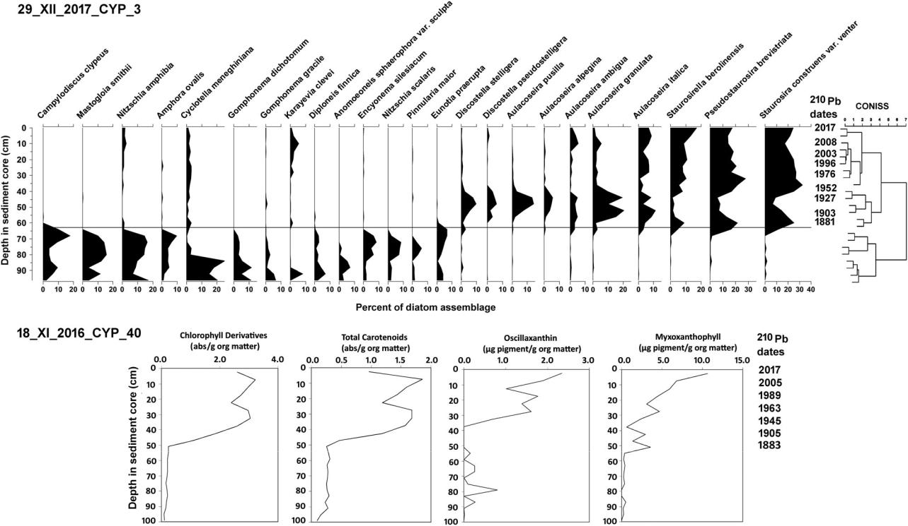

Figure 2. Diatom profile with CONISS zonation for core 29_XII_2017_CYP_3 from Lake Cypress. Lower panels show sedimented algal and cyanobacterial pigment profiles from Lake Cypress core 18_XI_2016_CYP_40.

conditions prior to the 1880s. Constrained incre-mental sum of squares hierarchical agglomerative cluster analysis (CONISS) and the broken-stick model showed that a statistically significant change in diatom assemblages occurred c. 1881 (Figure 2). Salt-tolerant taxa disappeared in all 3 cores around the time of engineered water-level changes, after which there was a transition to dominance by Aulacoseira granulata, a eutrophic species (opti-mum total P ¼ 45 mg/L; Whitmore et al. 2018) that requires open waters for suspension in the water column. Another change occurred in the early 1900s to dominance by hypereutrophic, tycho-planktonic Pseudostaurosira brevistriata and Staurosira construens var. venter (optimum total P, respectively, ¼ 127 mg/L and 89 mg/L), which our studies have shown is often associated with cyano-bacteria in the water column (Whitmore et al. 2018). Tychoplanktonic taxa spend much of their life histories growing on surfaces, but they are intermittently suspended in the water column by waves and currents. Diatom-based water quality inferences from Lake Cypress were not available because the mixed salt-tolerant assemblages in the lower halves of the cores had no analogs among lakes in the calibration set (Table S1).

Pigment concentrations in the sediments are shown for core 18_XI_2016_CYP_40 (Figure 2). Chlorophyll and carotenoid pigment values were stable below 50 cm in the core, then increased rapidly more than 3-fold after 1883 when Lake Cypress was connected to the Kissimmee Chain by canals. The cyanobacterial pigments oscillax-anthin and myxoxanthophyll were present occa-sionally prior to 1945, then increased more than 10-fold to the present time (Figure 2). Total P deposition rates increased 19-fold, and total N increased 3.5-fold since c. 1855.

The plot of d13C versus C/N ratios showed that sedimented carbon at the base of the core was composed primarily of submerged aquatic plants and epiphytic algae (Figure 3). Sediment carbon sources initially were largely floating-leaved vegetation, and then in the top 40 cm of the core (since c. 1945), sources were cyanobac-teria and/or algae that used atmospheric CO2 for photosynthesis. In predisturbance samples of core 18_XI_2016_CYP_40, Taxodium (cypress) pollen represented about 5% of the assemblage, which was a low-level indication that there were associ-ated swamps in the area. Taxodium pollen was comparatively rare in the other 2 cores (Table

10  T. J. WHITMORE ET AL.

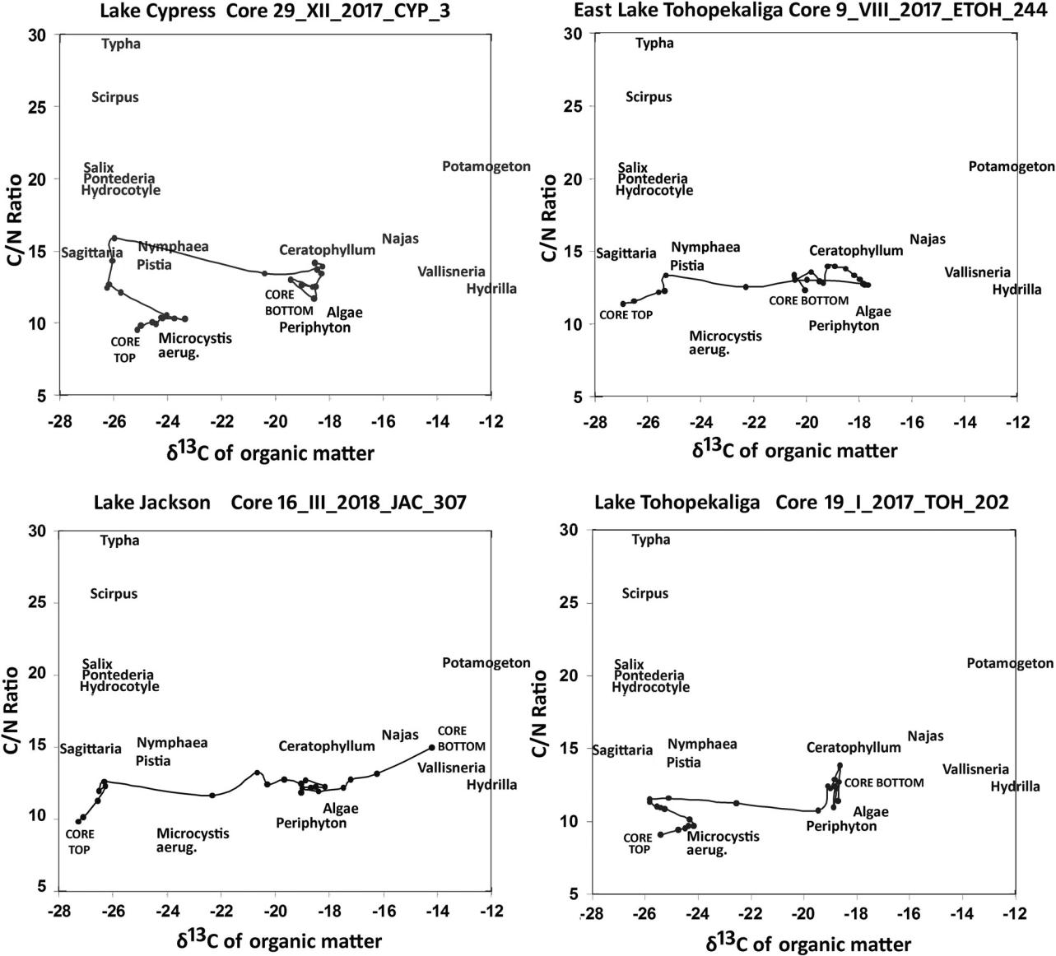

Figure 3. Plots of d13C versus C/N ratios in sedimented organic matter for cores from Lakes Cypress, East Tohopekaliga, Jackson, and Tohopekaliga, the 4 lakes that showed prominent changes in primary producer communities over time. Specific taxa are placed in relative positions based on d13C and C/N values reported for studies of other Florida lakes, and are used here to provide general indication of trends in community change.

S7). Pollen from other wetland taxa Morella (bay-berry), Nyssa (water tupelo), and Salix (willow) also were present. Pollen data from the predis-turbance period indicated the presence of Pontederia, Typha, Sagittaria, Nymphaea, Nuphar, and Myriophyllum. Macrofossil analyses showed abundant Chara in lowermost predisturbance samples, which was evidence of relatively clear waters (Table S13). Chara declined rapidly prior to the 1880s and was replaced by Nymphaea, a shift that often occurs with eutrophication and diminished light availability (Blindow 1992, Sayer et al. 2010a, 2010b, Bennion et al. 2018). Plant

macrofossils during the predisturbance period also included remains of Najas and Potamogeton.

East Lake Tohopekaliga

Radioistopic activities for East Lake Tohopekaliga core 9_VIII_2017_ETOH_244 are shown in Figure S2, and dates are shown in Table S2. In profiles of 2 cores from East Lake Tohopekaliga, diatoms were nearly absent from segments of

10 cm in each record because of substantial breakage. This breakage occurred in core 9_VIII_2017_ETOH_244 around the 25–35 cm

LAKE AND RESERVOIR MANAGEMENT  11

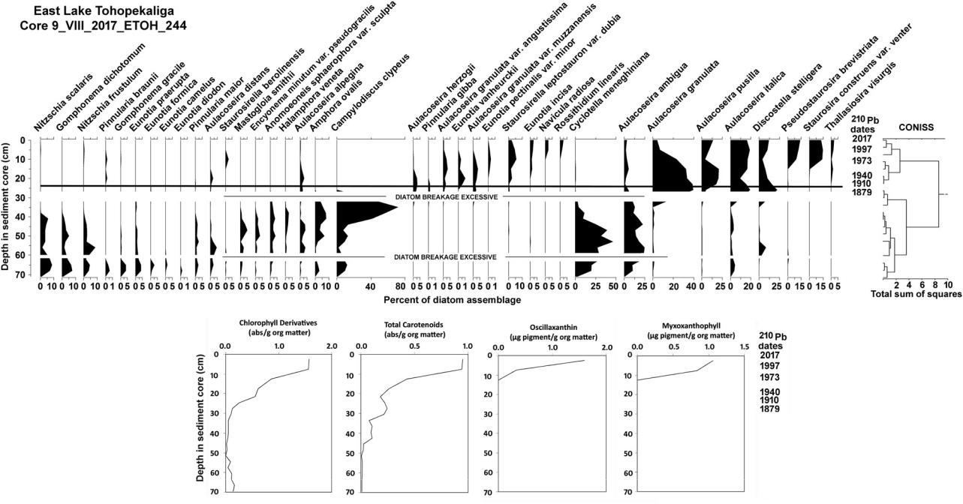

Figure 4. Diatom profile with CONISS zonation for core 9_VIII_2017_ETOH_244 from East Lake Tohopekaliga. Lower panels show sedimented algal and cyanobacterial pigment profiles.

depth (Figure 4). Diatoms below that level, prin-cipally those toward the left in Figure 4, were largely benthic and epiphytic taxa. Several benthic taxa below the 30-cm level were noteworthy for high salinity tolerances, and those included Nitzschia scalaris, Mastogloia smithii, Anomoeoneis sphaerophora var. sculpta, and particularly Campylodiscus clypeus. Prior to 1879, salt-tolerant diatoms co-occurred with Cyclotella meneghiniana and Aulacoseira ambigua, which are eutrophic indicators (A. ambigua optimum total P ¼ 49 mg/L; Whitmore et al. 2018) that typically occur as plankton in the open-water limnetic zone of lakes. These mixed assemblages suggested extreme fluc-tuations in water levels. An increase to a high per-centage (72%) of C. clypeus above the 40-cm level indicated that the large preservation hiatus in Figure 4 was a prolonged low water-level event. CONISS showed statistically significant changes in diatom assemblages after c. 1879 (Figure 4). These changes occurred around the time (1883) that water levels were changed permanently by canal construction. Dominance shifted to planktonic Aulacoseira granulata until c. 1980, then to tycho-planktonic Pseudostaurosira brevistriata and Staurosira construens var. venter, which indicated persistent cyanobacteria (Whitmore et al. 2018). Diatom-based water quality inferences for the

early history of East Lake Tohopekaliga were not available because mixed salt-tolerant assemblages in the lower portions of the cores resulted in those samples having no analogs in the calibration set (Table S2).

Percent native chlorophyll values for core 9_VIII_2017_ETOH_244 indicated fairly consist-ent pigment preservation throughout the core. Chlorophyll derivatives and total carotenoid val-ues were low below the 45-cm level in the core (no date available), then increased from c. 1879 to the 1970s (Figure 4). Myxoxanthophyll and oscillaxanthin cyanobacterial pigments appeared only above the 10-cm level (c. 1973: Figure 4), which was consistent with the timing of diatom indication of cyanobacteria influence.

d13C and C/N ratios (Figure 3) showed that carbon deposited in predisturbance basal sedi-ments was largely from submerged vegetation and epiphytic algal sources. Sedimented carbon sources progressed to floating-leaved vegetation toward the core top, and a recent decrease in C/ N ratios possibly indicated cyanobacterial influ-ence. Pollen grains in predisturbance samples were generally sparse, and Taxodium (cypress) and Morella (bayberry) pollen were low in abun-dance despite the reported presence of associated swamps before the 1880s. Pollen grains, however,

12  T. J. WHITMORE ET AL.

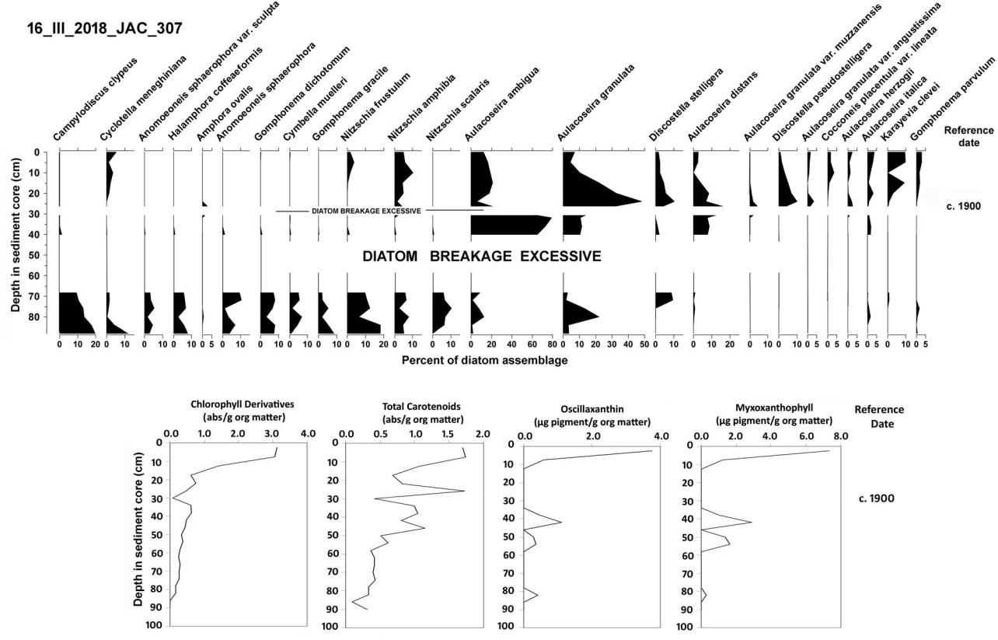

Figure 5. Diatom profile for core 16_III_2018_ JAC _307 from Lake Jackson. Lower panels show sedimented algal and cyanobac-terial pigment profiles. CONISS was not performed because of the broad gaps in diatom presence.

|  |  |  |
| --- | --- | --- |
| did show evidence of emergent and floating- | 40-cm levels showed extensive breakage that sug- |  |
| leaved Pontederia, Sagittaria, Nymphaea, Nuphar, | gested a long period of extremely low water levels, |  |
| and sedges, as well as submerged Myriophyllum | as in East Lake Tohopekaliga. Radioistopic activ- |  |
| and Potamogeton. Macrofossil evidence from pre- | ities for core 16_III_2018_ JAC _307 are presented |  |
| disturbance samples showed abundant Chara, | in Figure S3. Unsupported 210Pb activity showed |  |
| which indicated clear or shallow waters. In the | an abrupt decline at the 12.5-cm level (c. 1975), |  |
| 41–44-cm sample from the core, seeds of Ruppia | which suggested a possible hiatus caused by sedi- |  |
| maritima were observed, which indicated very | ment transport. As a result, we adopted a conser- |  |
| high solute concentrations prior to c. 1865. | vative approach and rejected the calculated 210Pb |  |
|  | dates, and assigned a nominal reference date of “c. |  |
| Lake Jackson | 1900” to the depth at which unsupported 210Pb |  |
| activity reached zero. The error term for excess |  |
|  |  |
| Below the 70-cm level in core 16_III_2018_ JAC | 210Pb activity in the 20–24-cm interval was greater |  |
| _307 (Figure 5), salt-tolerant diatoms were present | than the excess 210Pb activity value, so we set the |  |
| as in Lakes Cypress and East Tohopekaliga. These | date of “c. 1900” for 24 cm depth in the core. |  |
| taxa included Nitzschia scalaris, Anomoeoneis | Diatom assemblages changed significantly above |  |
| sphaerophora var. sculpta, Campylodiscus clypeus, | the section of extensive diatom breakage. The |  |
| and Halamphora coffeaeformis. These species co- | planktonic, eutrophic taxa Aulacoseira ambigua |  |
| occurred with eutrophic taxa that included | and A. granulata became dominant just before c. |  |
| Cyclotella meneghiniana, Aulacoseira ambigua, and | 1900, and salt-tolerant taxa no longer were pre- |  |
| A. granulata, with the latter two being planktonic | sent. Diatom assemblages near the top of the core |  |
| forms that indicated deeper limnetic waters. | showed an increase in some periphytic taxa (e.g., |  |
| Water-level fluctuations were suggested by these | Karayevia clevei) without prominent indication of |  |
| mixed assemblages. Diatoms between the 70- and | change in water quality, and the tychoplanktonic |  |

taxa that we associate with competitive exclusion by cyanobacteria were not present. As in Lakes Cypress and East Tohopekaliga, quantitative water quality inferences were not available because salt-tolerant assemblages in the lower portions of the cores resulted in samples having no analogs in the calibration set (Table S3). Equivocal dates did not permit estimation of changing rates of nutri-ent deposition.

Chlorophyll derivative values were low (<1.0 abs/g org matter) in sediments deposited prior to c. 1900 ( 30 cm) in core 16_III_2018_JAC_307, which indicated low historical algal productivity (Figure 5). Chlorophyll derivatives and total carotenoid concentrations increased to 2–3 abs/g above the 20-cm level. Percent native chlorophyll, the indicator of pigment preserva-tion quality, declined in the upper 28 cm of the core, which showed that pigment concen-tration increases were not an artifact of pres-ervation. Myxoxanthophyll and oscillaxanthin cyanobacterial pigments were present occa-sionally at low concentrations below the 15 cm level in the core, but they increased to 7.3 and 3.8 lg/g organic matter, respectively, in the top 10 cm.

d13C versus C/N ratios (Figure 3) indicated that carbon deposited in sediments at the bottom of the core was largely from submerged aquatic vegetation that might have included Vallisneria, Ceratophyllum, and Najas, as well as carbon from algae or periphyton. Sedimented carbon signa-tures changed to sources that probably included floating-leaved vegetation and algae/cyanobacteria toward the core top. Pollen analysis of predis-turbance samples at 70–100 cm deep in the core showed very low numbers of grains of the wet-land Taxodium (cypress), Nyssa (water tupelo), Salix (willow), and Morella (bayberry), but pollen was present from grasses and asters, such as are found in natural grasslands and dry prairies in the vicinity of the lake today (Table S9). Pollen analysis revealed Myriophyllum in predisturbance samples, and plant macrofossils included Chara, Najas, and some seeds of Nymphaea. Macrofossil remains showed that Chara was abundant in the 80–85 cm sample, but disappeared above that level in the core (Table S15).

|  |  |
| --- | --- |
| LAKE AND RESERVOIR MANAGEMENT | 13 |



Lake Tohopekaliga

Lake Tohopekaliga core 19_I_2017_TOH_202 was retrieved in the central basin of this 3-lobed lake. Radioistopic activities for core 19_I_2017_TOH_202 are shown in Figure S6, and dates are shown in Table S6. Diatom assemblages below the 60-cm level contained a large number of planktonic taxa that included Cyclotella meneghiniana, Synedra radians, and Cyclotella distinguenda. In addition, these samples included Anomoeoneis sphaerophora var. sculpta, Mastogloia smithii, M. braunii, and M. smithii var. lacustris, which indicated high solute concen-trations that resulted from low water-level condi-tions (Figure 6). We interpreted these mixed assemblages as being caused by large fluctuations in water level prior to the 1890s. CONISS and the broken-stick model showed a statistically sig-nificant change in diatom assemblages above the 60-cm level (c. 1890), and taxa indicative of high salinity conditions were no longer present. Eutrophic and planktonic species of Aulacoseira spp. became dominant around the 50-cm level in the core (c. 1916). After c. 1931, diatom domin-ance shifted to more highly eutrophic benthic taxa that included Pseudostaurosira brevistriata, Staurosirella berolinensis, and Staurosira con-struens. This transition suggested increased influ-ence of cyanobacteria on planktonic diatom assemblages (Whitmore et al. 2018). Salt-tolerant diatoms below the 50-cm level resulted in sam-ples that had no analogs in the calibration set (Table S6), so quantitative water quality infer-ences were not available.

Chlorophyll derivative concentrations were <0.3 abs/g organic matter below the 65-cm level (prior to 1897), and they increased steadily to about 4.0 abs/g organic matter at the top of the core (Figure 6). Total carotenoid concentrations varied around 0.5 abs/g organic matter below the 40 cm level in the core (c. 1950), then increased to 1–2 abs/g organic matter in the topmost sam-ples. Oscillaxanthin and myxoxanthophyll cyano-bacterial pigments were present and variable around 0.1–1 lg pigment/g organic matter below the 40 cm level, then increased to 2 lg pigment/

1. organic matter of oscillaxanthin and 5 lg pig-ment/g organic matter of myxoxanthophyll in the

14  T. J. WHITMORE ET AL.

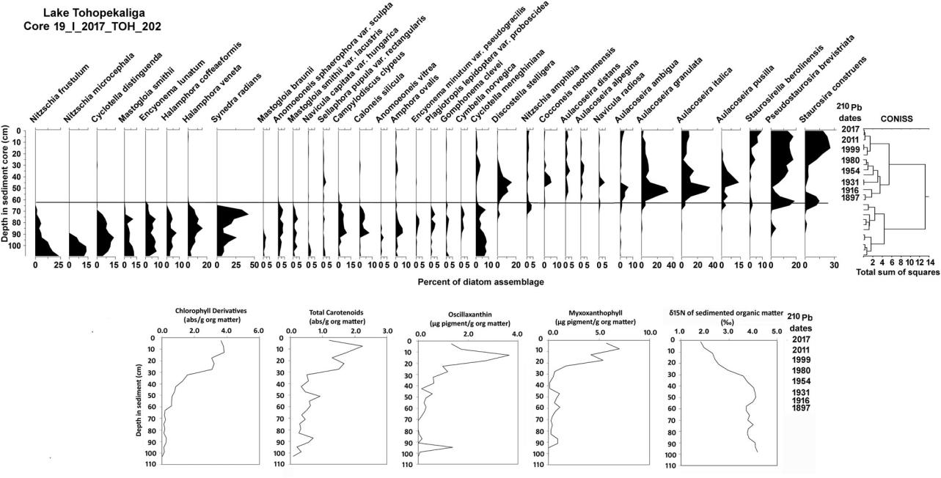

Figure 6. Diatom profile with CONISS zonation for core 19_I_2017_TOH_202 from Lake Tohopekaliga. Lower panels show sedi-mented algal and cyanobacterial pigment profiles.

topmost samples. Although d15N values of sedi-mented organic matter tended to be unchanged in all other lakes of this study, d15N values in Tohopekaliga core 19_I_2017_TOH_202 showed a decline (Figure 6) that is a typical response to nitrogen-fixing cyanobacteria (Brenner et al. 1999, Riedinger-Whitmore et al. 2005). The decline in d15N values was consistent with diatom evidence of increased cyanobacteria presence (Whitmore et al. 2018).

d13C versus C/N ratios indicated that sub-merged aquatic vegetation, periphyton, and algae were important sources of sedimented carbon prior to 1897, but signatures changed rapidly thereafter to reflect sources that included cyano-bacteria, algae, and possibly floating-leaved vege-tation (Figure 3).

Pollen from grasses, sedges, and asters in pre-disturbance samples ( 100–60 cm depth) indi-cated that marshes or open grasslands were present in the vicinity (Table S12). Pollen from wetland taxa, which included Taxodium, Salix, and Morella, were present only in very low num-bers. Pollen from Pontederia, Myriophyllum, and Typha domingensis were present. Plant macrofos-sils in predisturbance samples ( 113–60 cm depth) showed abundant Chara, which indicated clear or shallow waters. Nymphaea appeared

around 65 cm depth in the core as Chara declined (Table S18). Macrofossil analyses also showed Ruppia maritima seeds in predisturbance sediments of 3 cores from Lake Tohopekaliga, which indicated periods of very high solute con-centrations during predisturbance times. Ruppia appeared in 2 cores from the southern basin and in one core from the central basin. In one core from the southern basin, up to 111 Ruppia seeds were found in analyzed samples.

Ostracods showed evidence of very high solute concentrations as a result of extreme water-level fluctuations during predisturbance times. In the 113–89 cm levels of core 19_I_2017_TOH_202, freshwater to oligohaline ostracods included Darwinula stevensoni, Cyprideis salebrosa, Physocypria krapelini, Limnocythere floridensis, Limnocythere inopinata, and Cypridopsis vidua. Several of these taxa plus Cypretta brevisaepta and Cypridopsis okeechobei were present in pre-disturbance samples from a core in the southern basin. Ostracods were not observed again after the 1890s in any sediment samples. Their dis-appearance likely resulted from stabilized water levels that precluded high dissolved solute con-centrations, but reduction of macrophytes and increased sediment deposition also might have contributed to their decline (Keyser 1977,

LAKE AND RESERVOIR MANAGEMENT  15

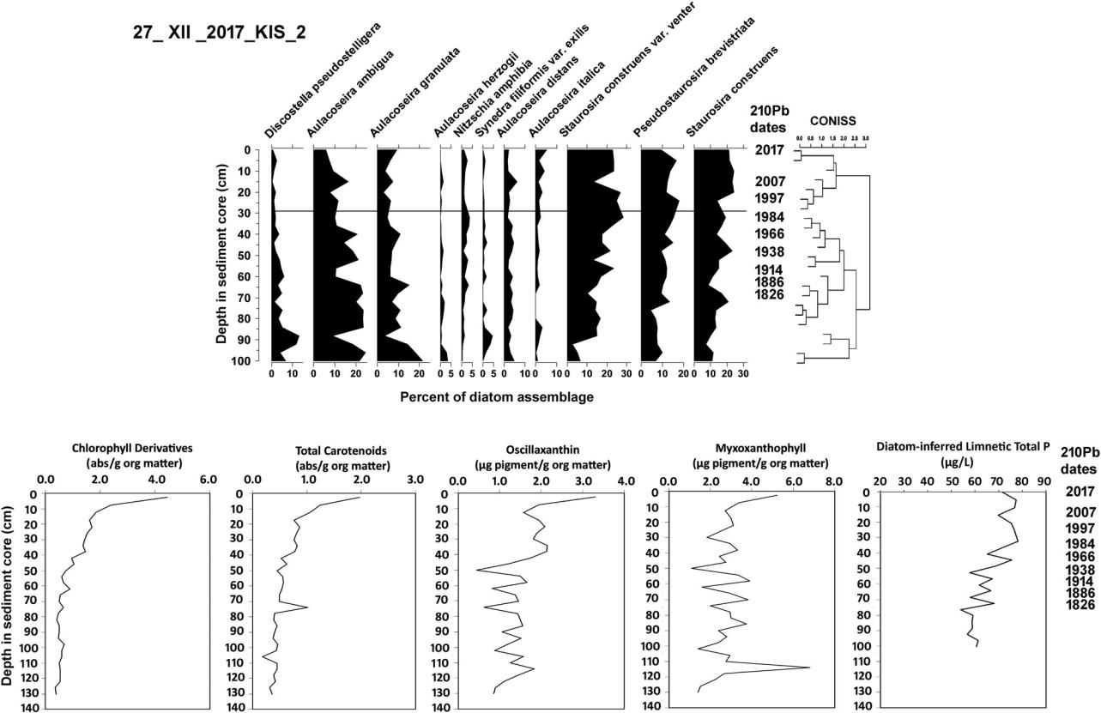

Figure 7. Diatom profile with CONISS zonation for core 27_XII_2017_KIS_2 from Lake Kissimmee. Lower panels show sedimented algal and cyanobacterial pigment profiles. Lower right panel presents diatom-based limnetic total P inferences.

Holmes 1992, Ruiz et al. 2013). Total P accumu-lation rates increased 4- to 12-fold in the central basin, and total N accumulation rates increased 4- to 23-fold.

Lake Kissimmee

Lake Kissimmee core 27_XII_2017_KIS_2 was retrieved from the main basin of the lake. Radioistopic activities for core 27_XII_2017_KIS_2 are shown in Figure S4, and dates are presented in Table S4. The diatom assemblage profile (Figure 7) shows that Aulacoseira spp. were pre-sent at 10% of assemblages or greater through-out the entire core. Pseudostaurosira brevistriata and Staurosira construens var. venter, which are most abundant during advanced eutrophication with cyanobacteria (Whitmore et al. 2018), were present consistently at percentages similar to Aulacoseira spp. These diatoms indicated that Lake Kissimmee was eutrophic and has sustained high productivity since well before 1826. Salt-toler-ant diatoms were not present in the Lake

Kissimmee cores, and analog matching results showed that diatom assemblages throughout the core had many analogs (5–13, generally >10) among lakes in the calibration set (Table S4). Diatom-based limnetic total P inferences obtained by weighted averaging for the predisturbance period were approximately 61 lg/L at the base of the core during the early 1800s, and they generally increased to the present time (Figure 7, Table S4). The Florida DEP provided a modern limnetic total P average of 64.1 lg/L for 2000–2006 (Table 1) for comparison, and our diatom-based limnetic total P inference for that time period was 76.6 lg/L. We note that the lake has highly variable water quality, with a limnetic total P range of 9–700 lg/ L during 2000–2006 (Polk County Water Atlas 2019), so although our inference is somewhat high, there might be a question about representa-tivity of the modern reported mean. Total P accu-mulation rates in core 27_XII_2017_KIS_2 increased approximately 74-fold from 1886 to the present time, and total N accumulation rates increased approximately 12-fold.

16  T. J. WHITMORE ET AL.

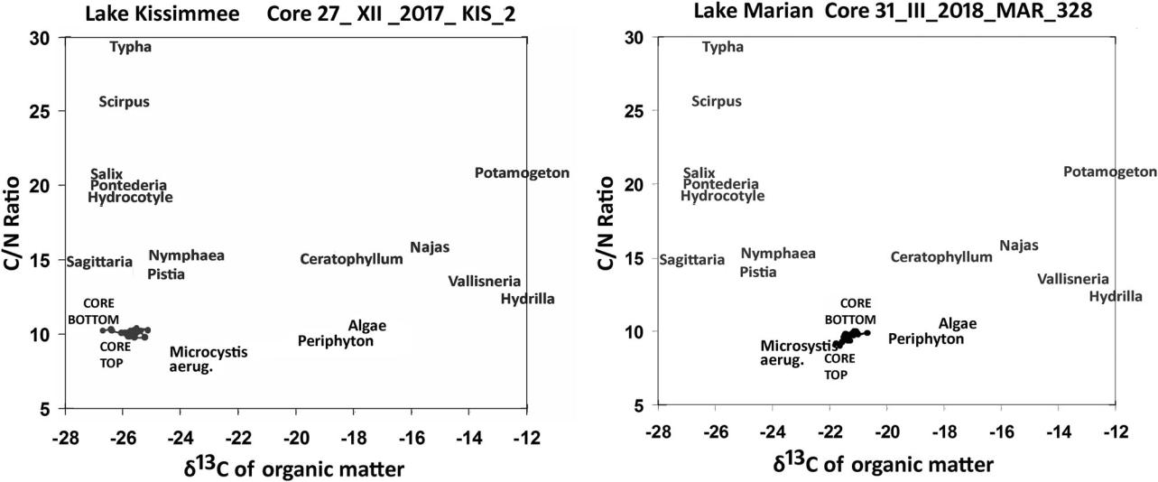

Figure 8. Plots of d13C versus C/N ratios in sedimented organic matter for cores from Lakes Kissimmee and Marian from the early 1800s until 2017. Both lakes lacked macrofossil evidence and were consistently dominated by algae and cyanobacteria over time. Specific taxa are placed in relative positions based on d13C and C/N values reported for studies of other Florida lakes, and are used here to provide general indication of trends in community change.

Chlorophyll derivative values were <1 abs/g organic matter below 50 cm (prior to 1880s) in core 27_XII_2017_KIS_2, then increased grad-ually above the 50 cm level to 4.4 abs/g organic matter at the top of the core (Figure 7). Total carotenoid values were <1 abs/g organic matter

below the 20 cm level (c. 1990), but increased

to 2 abs/g organic matter. Most notably, the cyanobacterial pigments myxoxanthophyll and oscillaxanthin were found throughout the Lake Kissimmee cores at values ranging from 1 to 6 lg pigment/g organic matter, which indicated that cyanobacteria populations were continuously pre-sent since prior to the 1880s.

d13C versus C/N ratios (Figure 8) were essen-tially unchanged throughout the length of the sediment core (since prior to 1826), and they suggested that carbon deposited in sediments was consistently influenced by cyanobacteria and algae, and possibly to some extent by floating-leaved vegetation as well.

Pollen from predisturbance samples showed high amounts of Taxodium grains ( 17% of assemblages), which indicated that swamps were associated with Lake Kissimmee prior to 1826. Pollen from the wetland taxa Nyssa, Salix, and Morella supported that conclusion (Table S10). Plant macrofossils showed virtually no evidence of submerged aquatic vegetation, but seeds from floating-leaved nymphaeids were present (Table

S16), which indicated turbid waters from algae/ cyanobacteria, or high dissolved organic carbon concentrations (color) from associated swamps.

Lake Marian

Radioisotopic activities for Lake Marian core 31_III_2018_MAR_328 are shown in Figure S5, and dates are shown in Table S5. In Lake Marian, as in Lake Kissimmee, diatoms showed highly productive conditions throughout the entire 1.5 m profile, with no evidence of salt-tolerant diatoms that would suggest water-level fluctuations (Figure 9). The eutrophic, plank-tonic diatom Aulacoseira ambigua represented 50–60% of diatoms in the assemblages from 150 to 100 cm depth in the core. A. ambigua progressively declined above the 100-cm level (c. 1898) to 10% of the assemblage at the top of the core, while Pseudostaurosira brevistriata, Staurosira construens, and Staurosirella beroli-nensis increased and represented 10–20% of the assemblage at the core top. This shift is consist-ent with increased competitive exclusion of planktonic diatom taxa by cyanobacteria (Whitmore et al. 2018). Diatom samples in the core had 7–9 analogs in the calibration set before c. 1837, and 12–15 analogs at all depths higher than that in the core (Table S5).

LAKE AND RESERVOIR MANAGEMENT  17

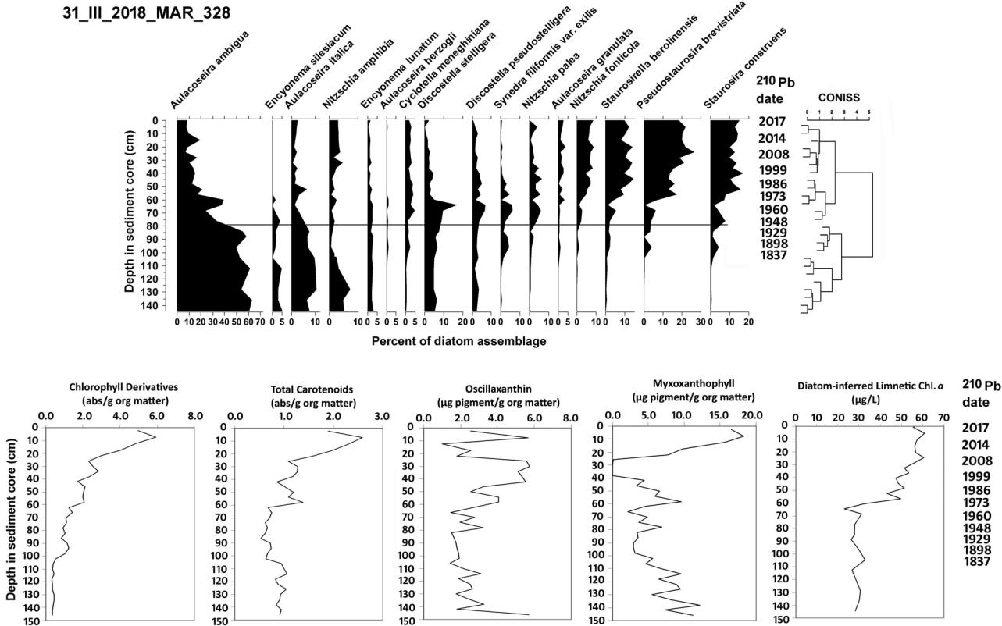

Figure 9. Diatom profile with CONISS zonation for core 31_III_2018_MAR_328 from Lake Marian. Lower panels show sedimented algal and cyanobacterial pigment profiles. Lower right panel presents diatom-based limnetic chlorophyll a inferences.

The Florida DEP provided a mean of measured limnetic total P for 2000–2006 of 155 lg/L, and our diatom-inferred value for that period was 82.1 lg/L, which substantially underestimated the reported value. The modern measured value is beyond the reliable range of our total P inference model, and we suspect at least intermittent nitrogen limitation in Lake Marian. As a result, we rejected use of the limnetic total P inference model for Lake Marian. Instead, we applied the weighted-averaging model that is used to infer chlorophyll a from diatom assemblages in sediments. The Florida DEP reported a measured mean chlorophyll a value of 54.5 lg/L for 2000–2006, and our inferred value was 53.6 lg/L for that period, which indicated reli-able performance. Limnetic chlorophyll a inferences for Lake Marian are shown in Figure 9 and Table S5. Inferred limnetic chlorophyll a at the base of the core, which was deposited well before c. 1837, was 28.3 lg/L. Limnetic chlorophyll a, therefore, increased significantly in Lake Marian from the early 1800s to the present time.

Chlorophyll derivatives and total carotenoid concentrations were <1.0 abs/g organic matter c.

1837 (Figure 9). Chlorophyll derivatives increased progressively after c. 1898 to 5 abs/g organic matter at the top of the core. Total carotenoids increased rapidly after c. 1960–1973 to 2 abs/g organic matter at the top of the core (Figure 9). Myxoxanthophyll and oscillaxanthin cyanobacter-ial pigment concentrations showed considerable variation over time, but prior to c. 1837, they were nearly as high as during recent decades. Myxoxanthopyll increased rapidly after c. 1999.

As in Lake Kissimmee, stable isotopes and C/ N ratios of organic matter in sediments showed that algae and cyanobacteria, and possibly some floating-leaved macrophytes, were the primary sources of sediment organic matter from prior to 1837 up to the present time (Figure 8). Macrofossil remains were very sparse, with no indication of submerged aquatic vegetation, and only a few sclereids of nymphaeids were found in one core in deposits that dated to the early 1900s (Table S17). Pollen grains of Taxodium ( 13–17% of assemblages) as well as Morella (bayberry) were abundant in samples prior to 1837 (Table S11), which indicated that swamps

18  T. J. WHITMORE ET AL.

were well established in the vicinity of Lake Marian. Pollen and macrofossil evidence, there-fore, supported an interpretation of waters that were high in algae/cyanobacteria concentrations, as well as possible high color from dissolved organic carbon from associated swamps.

Discussion

Predisturbance water quality and eutrophication

Eutrophication occurred in all of the study lakes to varying degrees. This was evidenced by increased deposition rates of phosphorus and nitrogen, by increased sedimented pigment con-centrations of algae and cyanobacteria, and by diatom autecology and statistical inferences of water quality. d13C versus C/N plots and plant macrofossils in Lakes Cypress, East Tohopeliga, Jackson, and Tohopekaliga showed a shift from submerged plant communities to floating-leaved taxa, then to algae/cyanobacteria, a progression that is typical of light limitation caused by eutrophication (Sayer et al. 2010a, 2010b, Bennion et al. 2018). Multiple lines of evidence showed that all lakes in this study were meso-eutrophic to eutrophic during predisturbance times. None of the lakes in this study held oligo-trophic waters during their reference periods in the early 1800s. Qualitative diatom evidence based on well-documented autecological preferen-ces in the literature, as well as the limnetic total P optima reported for dominant taxa (Whitmore et al. 2018), showed that Lakes Cypress, East Tohopekaliga, Jackson, and Tohopekaliga had high productivity during their predisturbance periods in the early 1800s. Predisturbance infer-ences for limnetic total P in Lake Kissimmee (61 lg/L) and for limnetic chlorophyll a in Lake Marian (28.3 lg/L) were within the eutrophic range for lakes.

High productivity in these lakes during their predisturbance periods is consistent with their geological setting. Paleolimnological studies have shown that a significant number of Florida lakes, particularly alkaline lakes with color, were pro-ductive during predisturbance periods because of naturally high edaphic nutrient supply (e.g., Brenner et al. 1993, Riedinger-Whitmore et al.

2005, Kenney et al. 2014). For such lakes, nutri-ent criteria standards <40–45 mg/L total P would not be appropriate. Naturally high productivity in lakes on the Kissimmee Chain suggests that rela-tively small amounts of nutrient additions could occur before modern nutrient criteria standards would be exceeded. Paleolimnological studies have demonstrated naturally high productivity and sustained cyanobacterial populations in other regions as well (McGowan et al. 1999, Brooks et al. 2001, Simmatis et al. 2020).

In Lakes Cypress, East Tohopekaliga, Tohopekaliga, and Marian, diatom communities changed in response to increased cyanobacteria presence. Tychoplanktonic taxa increased as cyanobacteria became well established and plank-tonic taxa, including Aulacoseira spp., were sub-ject to competitive exclusion (Whitmore et al. 2018). Although this shift might seem paradox-ical in hypereutrophic conditions because of potential light limitation of algae that grow on surfaces, frequent mixing in Florida’s shallow, wind-stressed lakes affords tychoplanktonic taxa the opportunity to meet minimum light require-ments. Recognition of this community shift might serve as an early warning indicator of pending system changes in modern Florida lakes, and it might be used to better inform decisions about lake management (Reavie 2019). This diatom community change was not evident in Lake Jackson, however, and sedimented pig-ments showed that cyanobacteria increased in that lake only recently. Lakes Kissimmee and Marian sustained substantial cyanobacteria pop-ulations throughout their entire records since the early 1800s.

Associated wetlands and their possible influence on lake color

Carpenter et al. (1998) showed strong effects of dissolved organic color on chlorophyll concentra-tions and primary production in lakes because of light attenuation in the water column. Persistent and highly colored humic and fulvic acids that contribute to colored dissolved organic carbon (C-DOC) in lakes often have allochthonous sour-ces from nearby wetlands, although pine flat-woods in Florida often contribute C-DOC

because shallow, impervious clay layers direct tan-nins laterally to nearby waterbodies. In contrast, autochthonous DOC from the breakdown of phyto-plankton and macrophyte biomass is less highly colored and is easily degraded. Because of its poten-tial for moderating primary production, Williamson et al. (1999) maintained that there is a clear need to incorporate C-DOC into lake management approaches. However, C-DOC is not equally effect-ive in controlling algal production in lakes across a wide range of trophic states. Carpenter et al. (1998) stated that eutrophication is responsible for a broad range of P inputs to lakes, and this strong environ-mental gradient tends to mask the effects of C-DOC in multiple-lake comparisons. Karlsson et al. (2009) concluded that light availability, as influ-enced by C-DOC, controls productivity most effect-ively in low-productivity lakes, whereas nutrient availability controls productivity in lakes that are eutrophic and dominated by pelagic production. Based on these studies, it seems appropriate to con-clude that the potential moderating effect of C-DOC on primary productivity is likely to be more effective during periods of low disturbance than it is when lakes have undergone advanced eutrophica-tion. This suggests the importance of protecting associated wetlands for lakes that have not been subject to high nutrient loading, and for imple-menting wetland restoration after high nutrient concentrations have been reduced.

At the beginning of the 1800s, wetlands cov-ered nearly 50% of the surface area of Florida (Fernald and Purdum 1998). Subsequent logging and alteration of lake levels caused substantial loss of wetlands associated with Florida’s 8000 lakes. When the present study was initiated, the Osceola County Public Works Department con-ducted a statistical evaluation of water quality measures for a large set of lakes to determine whether C-DOC has a moderating influence on phytoplankton concentrations in this region. Limnetic concentrations of total nitrogen, total phosphorus, and chlorophyll a were compared for 2 categories: lakes with low color concentra-tions (i.e., <75 platinum cobalt units; PCU) and lakes with high color concentrations (>75 PCU). Results showed that nutrient concentrations were likely to be higher under high color conditions, but concentrations of chlorophyll a were likely to

LAKE AND RESERVOIR MANAGEMENT  19

be lower under high color conditions. The Osceola County and Florida DEP concluded that C-DOC has the potential to alter relationships between watershed loadings and in-lake concentrations of chlorophyll a in Kissimmee Basin lakes.

Lakes Kissimmee and Marian showed high pol-len concentrations of Taxodium (cypress), Nyssa (water tupelo), Salix (willow), and Morella in bot-tommost core samples, which indicated clear asso-ciation of swamps with the lakes. Macrofossil evidence was scarce, except for floating-leaved nymphaeids that can grow in waters with high color or turbidity. There was little evidence for submerged aquatic-plant communities. Our conclu-sion is that during predisturbance times in Lakes Kissimmee and Marian, waters were high in C-DOC that probably moderated algal productivity.

In contrast, pollen in reference samples from Lakes East Tohopekaliga and Tohopekaliga showed relatively little evidence of swamp taxa, and macro-fossils showed substantial amounts of Chara and Ruppia that indicated clear waters (Dressler et al. 1987, Bennion et al. 2018). This also was the case with Lakes Cypress and Jackson, but they lacked Ruppia in early deposits. Because historical drain-age reports indicated that some swamps were pre-sent near Cypress, East Tohopekaliga, and Tohopekaliga (Atlantic and Gulf Coast Canal and Okeechobee Land Company 1885), it might be appropriate to consider restoration efforts to sup-port associated wetlands near those lakes. We con-cluded from pollen evidence, however, that Lake Jackson had fairly clear waters and apparently lacked associated swamps that might have contrib-uted significant amounts of C-DOC.

Regarding the question of whether restoring more natural water levels and colored dissolved organic carbon concentrations might mitigate algal productivity and alter restoration strategies in lakes on the Kissimmee Chain, we recommend that this approach should first be implemented for Lakes Kissimmee and Marian, because paleo-limnological evidence showed greater original wetland presence for those lakes.

Historical changes in lake water levels

Modern water levels in lakes of the Kissimmee Chain are substantially lower than they were

20  T. J. WHITMORE ET AL.

prior to engineered drainage activities that began in the 1880s. Decreases in water levels during the 19th and 20th centuries contributed to management challenges, such as a greater potential for internal nutrient loading from sediment resuspension over a larger portion of the lake areas (e.g., Nagid et al. 2001), a reduced volume of water that would make the lakes more susceptible to eutrophication for a given increase in nutrient loading, and a potential loss of allochthonous C-DOC from associated wet-lands that might have helped to moderate algal production by light limitation.

A potentially greater disturbance resulted from reducing the large natural variations in water lev-els that prevailed prior to engineered changes. It was speculated that water levels in Kissimmee Chain lakes fluctuated during predisturbance times up to 3 m (US Army Corps of Engineers 1996), and that was confirmed by the present study. Salinity preferences of diatoms, macrofos-sils, and ostracods showed that these fluctuations greatly exceeded seasonal water-level variations, and that they occasionally led to total drying in portions of the lakes. Large water-level fluctua-tions would have increased habitat diversity and helped to maintain the integrity of the lake eco-systems, and natural fires during low water levels would have burned organic matter in exposed lit-toral areas (US Army Corps of Engineers 1996). Early natural fires were evident from charcoal that appeared periodically in diatom samples of the pre-sent study, although charcoal was not analyzed in detail. Multiple indicators in all sediment cores showed that Lakes Cypress, East Tohopekaliga, Jackson, and Tohopekaliga changed significantly after the 1880s because they failed to undergo very low water-level events that concentrated solutes on a periodic basis. Modern water levels are held rela-tively constant (within 0.6–0.9 m) by the South Florida Water Management District (Osceola County Community Development Department 2015). This has promoted organic matter accumu-lation, and favored proliferation of certain nuisance plants such as Hydrilla over native plants that depend on seasonal water-level variations for propagation. Results of the present study show that the cessation of natural water-level fluctuations had greater impact on lake processes, water quality, and community compositions than generally has

been recognized. Changes in water-level fluctua-tions were shown to affect the structure and func-tion of shallow lakes in other paleolimnological studies as well (e.g., Levi et al. 2016).

The most prominent diatom indicator of high solute conditions during extreme low water-level events in Lakes Cypress, East Tohopekaliga, Jackson, and Tohopekaliga was Campylodiscus clypeus. Poulickova and Jahn (2007) described this species as widespread mostly in hypersaline waters, but at specific conductance values begin-ning as low as 2000–3000 lS/cm, and where dominant anions tend to be carbonate or sulfate rather than chloride. Carvalho et al. (1995) reported that Campylodiscus clypeus occurred most often in hypersaline sites with Anomoeoneis sphaerophora var. costata. In the present study we observed Anomoeoneis sphaerophora var. cos-tata, as well as two of its salt-tolerant varieties.

Ruppia maritima seeds were abundant in cores from Lakes Tohopekaliga and East Tohopekaliga prior to 1880. Although Ruppia is often described as an estuarine plant in areas of lower salinity, it is actually a freshwater plant that has pronounced salinity tolerance, and it occurs in clear waters <2.0 m deep (Zieman 1982, Kantrud 1991). We have collected Ruppia, for example, in the littoral zone of a freshwater Florida lake that has a spe-cific conductance of about 1500 lS/cm. Ruppia seeds are ingested by waterfowl and can be trans-ported 280 km (Charalambidou et al. 2003), so it could have been distributed from coastal areas to these lakes during low water-level stands. Its presence in the sediment record of inland lakes provides clear indication of former elevated con-centrations of dissolved solutes.

Ostracods provided additional evidence of ele-vated dissolved solute concentrations at the base of several Lake Tohopekaliga cores. Darwinula stevensoni, Limnocythere inopinata, and Cypridopsis vidua occur in fresh to oligohaline waters (Keyser 1977, Holmes 1992, Ruiz et al. 2013). Cypridopsis okeechobei has an optimum range of 0.3–0.5 ppt salinity (Keyser 1977, Holmes 1992). Cypretta brevisaepta is an oligoha-line indicator that occurs below 0.5 ppt, but it has an optimum range of 0.5–1 ppt (Keyser 1977). Limnocythere inopinata and Cypridopsis vidua prefer organic substrates with vegetative

cover and are often associated with Chara (Matsuda et al. 2015), as they were in core sam-ples prior to c. 1890. Ostracods were absent in Lake Tohopekaliga after c. 1890, which signaled the disappearance of naturally low water levels. It appears evident that the hydrological alterations that began in 1883 prevented extremely low water levels after that time.

Many shallow Florida lakes are subject to very large fluctuations in water level, in part because of elution, or downward leakage in karst bedrock (Deevey 1988), which contributes to falling levels during drier periods. Natural fluctuations up to 3.5 m have been demonstrated in multiple-year studies of Florida lakes (Hoyer et al. 2005), and up to 10 m in lakes that are astatic (Deevey 1988). Large water-level fluctuations are not caused so much by precipitation in a given year, but by cumulative interannual precipitation pat-terns that affect groundwater levels on the order of decades (Deevey 1988).

Because most Florida lakes are shallow (<5 m), water-level fluctuations can greatly affect lake area and volume. We calculated the percent volume curve for modern Lake Tohopekaliga using con-tour areas and depths indicated in a contemporary morphometric map (UF/IFAS 2019). A drop of 2 m in current water level would reduce the lake to 23% of its volume, and would expose 37% of

the lake area to drying. A drop of 3 m in Tohopekaliga would reduce the current volume to 4%, and would expose 70% of the lake bed to dry-ing, which could easily increase total dissolved sol-ids sufficiently to support salt-tolerant taxa. Although downward elution likely would have removed some solutes as well as water during drier periods (Deevey 1988), the lakes in this study achieved impressively high salinities, as indicated by diverse biological evidence, so evaporation had to exceed leakage by a substantial amount.

Lakes Kissimmee and Marian did not show evidence of extreme water-level fluctuations like the other lakes, and they demonstrated the clear-est evidence of associated wetlands. We note that predisturbance water levels in East Tohopekaliga

|  |  |  |  |  |
| --- | --- | --- | --- | --- |
| (70.3 ft, | 21.4 m) | and Tohopekaliga | (64.6 ft, | |
| 19.7 m) | stood at higher elevations than | | | in |
| Kissimmee (59.1 ft, 18.0 m; surveyed prior to | | | | the |
| NGVD | elevation | standard: Atlantic | and Gulf | |

LAKE AND RESERVOIR MANAGEMENT  21

Coast Canal and Okeechobee Land Company 1885). Although the predisturbance water level of Lake Cypress was not reported, it would have been between 60 and 64 ft (18.3–19.5 m). It appears that local hydrological factors made Kissimmee and Marian less subject to drying than East Tohopekaliga, Tohopekaliga, and Cypress, which stood at higher elevations. Lake Jackson is situated between Kissimmee and Marian, but it showed evidence of high solutes and dry periods that Kissimmee and Marian did not. Jackson has been bordered by dry prairies historically, so it has a different edaphic setting. Jackson and Cypress are the smallest and volu-metrically shallowest lakes in this study: a 2-m water-level drop would currently reduce both lakes to <1% of their volume, and a 3-m drop would cause the lakes to go dry.

Conclusions

Two major types of changes occurred in these lakes during the late 19th and 20th centuries. All lakes in this study were meso-eutrophic prior to the mid 1800s, but eutrophication was observed in 5 of the 6 lakes, as shown by multiple lines of evidence. East Lake Tohopekaliga showed the least evidence of nutrient changes, and eutrophication was most pronounced in Lake Marian. Onset of eutrophication began in the late 1800s immedi-ately after engineered hydrological changes, and it increased distinctly during the 20th century because of nutrient loading that likely arose from urbanization, land-use change, agriculture, and cattle ranching. Engineered connection of the lakes facilitated a downstream cascade of nutrients, and the loss of former connecting wetlands reduced the biological filtering of nutrients that occurred prior to disturbance.

The second and possibly more prominent change in 4 of the 6 lakes was that hydrology was altered dramatically, both by lowering water levels with respect to former associated wetlands and, importantly, by permanently preventing the lakes from undergoing natural large fluctuations in water levels. This was evident in Lakes Cypress, East Tohopekaliga, Jackson, and Tohopekaliga, but was not the case in Lakes Kissimmee and Marian. Large natural

22  T. J. WHITMORE ET AL.

fluctuations influenced the types of native plant communities that were present, whereas more static water levels in recent times have contrib-uted to organic matter accumulation and high standing crops of aquatic plants. Although lake levels have been lowered occasionally in recent decades so littoral sediments can be scraped and burned, this is mechanically doing the work that natural processes did before engineered activities prevented large natural fluctuations in water levels.

Current management approaches often empha-size in-lake nutrient concentrations and mitiga-tion without adequately considering other significant changes in ecology or ecosystem func-tion, but restoration cannot be effective when it regards system changes as univariate (Davidson et al. 2018). Contemporary challenges for man-agement of these lakes include satisfying stake-holder needs related to the sport-fishing economy, recreational uses, water supply, and flood prevention. The lakes, however, are dis-tinctly out of balance with respect to nutrient content and recycling, standing crops of native and invasive plants, and the accumulation of nutrient-rich organic sediments. Considerable energy and costs are required for periodic draw-downs, scraping of sediments, and management of aquatic plants. The sustained connection of the lakes, which originated as a 19th-century paradigm, also facilitates transport of nutrients through the Kissimmee–Okeechobee–Everglades system, and it contributes to downstream restor-ation challenges.

Based on the findings of this study, we recom-mend disconnecting the lakes from each other and from the Kissimmee River to reestablish large, nat-ural fluctuations in water levels that were part of healthy ecosystem function. Some structures might need to be retained but modified to prevent flood-ing in developed areas. The current downstream nutrient cascade challenges local management agencies to deal with nutrient loads that arise partly outside of their jurisdictions. Hydrological restoration would return nutrient loading to being more of a local issue. Former wetlands between the lakes should be restored because this would reestablish biological communities that sequester nutrients that currently enter the lakes and river

system, and that subsequently reach Lake Okeechobee, the Everglades, and offshore coral reef systems.

The focus of the 19th and early 20th centuries was on making engineered changes in natural sys-tems for perceived human benefit, but that led to many unanticipated problems in lakes on the Kissimmee Chain. We advocate for a management paradigm in the 21st century that places greater emphasis on sustainability, reduced energy expenditure, and restoring the benefits that were provided by natural ecosystem functions.

Acknowledgments

We are particularly grateful to Susan Gosselin (Osceola County Public Works Department) and to Kimberly Lawrence (Reedy Creek Improvement District) for their support of our study. Three anonymous reviewers provided helpful feedback. Neil Rose arranged for radioisotopic dat-ing at the Environmental Change Research Centre at University College London. Mark Brenner provided valuable suggestions that helped to improve the article. Kendal Jackson assisted in the field.

Funding

This study was funded in part by Osceola County Public Works Department and the Florida Department of Environmental Protection.

References

Appleby PG, Nolan PJ, Gifford DW, Godfrey MJ, Oldfield F, Anderson NJ, Battarbee RW. 1986. 210Pb dating by low background gamma counting. Hydrobiologia. 143(1): 21–27. doi:[10.1007/BF00026640](https://doi.org/10.1007/BF00026640).

Appleby PG, Oldfield F. 1983. The assessment of 210Pb data from sites with varying sediment accumulation rates. Hydrobiologia. 103(1):29–35. doi:[10.1007/BF00028424](https://doi.org/10.1007/BF00028424).

Appleby PG, Richardson N, Nolan PJ. 1992. Self-absorp-tion corrections for well-type germanium detectors. Nucl Inst Methods B. 71(2):228–233. doi:[10.1016/0168-583X(92)95328-O](https://doi.org/10.1016/0168-583X(92)95328-O).

Battarbee RW, Bennion B. 2011. Palaeolimnology and its developing role in assessing the history and extent of human impact on lake ecosystems. J Paleolimnol. 45(4): 399–404. doi:[10.1007/s10933-010-9423-7](https://doi.org/10.1007/s10933-010-9423-7).

Bennett KD. 1996. Determination of the number of zones in a biostratigraphical sequence. New Phytol. 132(1): 155–170. doi:[10.1111/j.1469-8137.1996.tb04521.x](https://doi.org/10.1111/j.1469-8137.1996.tb04521.x).

Bennett KD, Willis KJ. 2001. Pollen. In: Smol JP, Birks HJ, Last WM, editors. Tracking environmental change using lake sediments volume 3: terrestrial, algal, and siliceous

indicators. Dordrecht, The Netherlands: Kluwer Academic Publications; p. 5–32.

Bennion H, Battarbee RW, Sayer CD, Simpson GL, Davidson TA. 2011. Defining reference conditions and restoration targets for lake ecosystems using palaeolim-nology: a synthesis. J Paleolimnol. 45(4):533–544. doi:[10.](https://doi.org/10.1007/s10933-010-9419-3) [1007/s10933-010-9419-3](https://doi.org/10.1007/s10933-010-9419-3).

Bennion H, Sayer CD, Clarke SJ, Davidson TA, Rose NL, Goldsmith B, Rawcliffe R, Burgess A, Clarke G, Turner S, Wiik E. 2018. Sedimentary macrofossil records reveal ecological change in English lakes: implications for con-servation. J Paleolimnol. 60(2):329–348. doi:[10.1007/](https://doi.org/10.1007/s10933-017-9941-7) [s10933-017-9941-7](https://doi.org/10.1007/s10933-017-9941-7).

Birks HH. 2017. Plant macrofossil introduction. In: Reference module in earth systems and environmental sciences. New York: Elsevier.

Blindow I. 1992. Decline of charophytes during eutrophica-tion: comparison with angiosperms. Freshwater Biol. 28(1):9–14. doi:[10.1111/j.1365-2427.1992.tb00557.x](https://doi.org/10.1111/j.1365-2427.1992.tb00557.x).

Brenner M, Hodell DA, Leyden BW, Curtis JH, Kenney WF, Gu BH, Newman JM. 2006. Mechanisms for organic matter and phosphorus burial in sediments of a shallow, subtropical, macrophyte-dominated lake. J Paleolimnol. 35(1):129–148. doi:[10.1007/s10933-005-7881-0](https://doi.org/10.1007/s10933-005-7881-0).

Brenner M, Whitmore TJ, Curtis JH, Hodell DA, Schelske CL. 1999. Stable isotopes (d13C and d15N) of sedimented organic matter as indicators of historic lake trophic state. J Paleolimnol. 22(2):205–221. doi:[10.1023/A:1008078222806](https://doi.org/10.1023/A:1008078222806).

Brenner M, Whitmore TJ, Flannery MS, Binford MW. 1993. Paleolimnological methods for defining target conditions in lake restoration: Florida case studies. Lake Reserv Manage. 7(2):209–217. doi:[10.1080/07438149309354272](https://doi.org/10.1080/07438149309354272).

Brooks SJ, Bennion H, Birks H. 2001. Tracing lake trophic history with a chironomid-total phosphorus inference model. Freshwater Biol. 46(4):513–533. doi:[10.1046/j.](https://doi.org/10.1046/j.1365-2427.2001.00684.x) [1365-2427.2001.00684.x](https://doi.org/10.1046/j.1365-2427.2001.00684.x).

Carpenter SR, Cole JJ, Kitchell JF, Pace ML. 1998. Impact of dissolved organic carbon, phosphorus, and grazing on zooplankton biomass and production in experimental lakes. Limnol Oceanogr. 43(1):73–80. doi:[10.4319/lo.1998.](https://doi.org/10.4319/lo.1998.43.1.0073) [43.1.0073](https://doi.org/10.4319/lo.1998.43.1.0073).

Carvalho LR, Sims PA, Battarbee RW, Cox EJ, Juggins S. 1995. Campylodiscus clypeus (Ehrenb.) Ehrenb. in inland saline Lakes In: Robertson AM, Hicks S, Akerlund A, Risberg J, Hackens T, editors. Landscapes and life: studies in honour of Uwe Miller. PACT. 50:471–484.

Charalambidou I, Santamaria L, Langevoord O. 2003. Effect of ingestion by five avian dispersers on the retention time, retrieval and germination of Ruppia maritima seeds. Funct Ecol. 17(6):747–753. doi:[10.1111/j.1365-2435.2003.](https://doi.org/10.1111/j.1365-2435.2003.00787.x) [00787.x](https://doi.org/10.1111/j.1365-2435.2003.00787.x).

Davidson TA, Bennion H, Reid M, Sayer CD, Whitmore TJ. 2018. Towards better integration of ecology in palaeo-ecology: from proxies to indicators, from inference to understanding. J Paleolimnol. 60(2):109–116. doi:[10.1007/](https://doi.org/10.1007/s10933-018-0032-1) [s10933-018-0032-1](https://doi.org/10.1007/s10933-018-0032-1).

LAKE AND RESERVOIR MANAGEMENT  23

Davidson TA, Jeppesen E. 2013. The role of palaeolimnol-ogy in assessing eutrophication and its impact on lakes.

1. Paleolimnol. 49(3):391–410. doi:[10.1007/s10933-012-9651-0](https://doi.org/10.1007/s10933-012-9651-0).

Deevey ES. Jr. 1988. Estimation of downward leakage from Florida lakes. Limnol Oceanogr. 33(6):1308–1320. doi:[10.](https://doi.org/10.4319/lo.1988.33.6.1308) [4319/lo.1988.33.6.1308](https://doi.org/10.4319/lo.1988.33.6.1308).

Diatoms of North America. 2020. Diatoms of North America. <https://diatoms.org/>.

Dierberg FE, Williams VP, Schneider WH. 1988. Evaluating water quality effects of lake management in Florida. Lake Reserv Manage. 4(2):101–111. doi:[10.1080/](https://doi.org/10.1080/07438148809354818) [07438148809354818](https://doi.org/10.1080/07438148809354818).

Dressler RL, Hall DW, Perkins KD, Williams NH. 1987. Identification manual for wetland plant species of Florida: used by the Florida department of environmental protection in determining the landward extent of waters of the State Institute of Food and Agricultural Sciences. SP-35. Univ. of Florida, Gainesville, FL; 297p.

Faegri K, Iversen J. 1989. Finding the grain: laboratory tech-nique. In: Faegri K, Kaland PE, Kryzwinski K, editors. Textbook of pollen analysis. 4th ed. Caldwell, NJ: The Blackburn Press; 328p.

Fernald EA, Purdum ED. 1998. Water resources Atlas of Florida. Tallahassee, FL: Florida State University, Institute of Science and Public Affairs; 282p.

Fisher MM, Brenner M, Reddy KR. 1992. A simple, inex-pensive piston corer for collecting undisturbed sediment/ water interface profiles. J Paleolimnnol. 7:157–161.

Florida Department of Environmental Protection (Florida DEP). 2013. Implementation of Florida’s Numeric Nutrient Standards. Tallahassee: Florida DEP; 86p.

Furtos NF. 1936. Fresh-water Ostracoda from Florida and North Carolina. Am Midl Nat. 17(2):491–522. doi:[10.](https://doi.org/10.2307/2419975) [2307/2419975](https://doi.org/10.2307/2419975).

Gu BH, Alexander V. 1996. Stable carbon isotope evidence for atmospheric CO2 uptake by cyanobacterial surface scums in a eutrophic lake. Appl Environ Microb. 62(5): 1803–1804. doi:[10.1128/AEM.62.5.1803-1804.1996](https://doi.org/10.1128/AEM.62.5.1803-1804.1996).

Heiri O, Lotter AF, Lemcke G. 2001. Loss on ignition as a method for estimating organic and carbonate content in sediments: reproducibility and comparability of results. J Paleolimnnol. 25(1):101–110. doi:[10.1023/A:1008119611481](https://doi.org/10.1023/A:1008119611481).

Holmes J. 1992. Non-marine ostracods as quaternary paleo-environmental indicators. Prog Phys Geogr. 16(4): 405–431. doi:[10.1177/030913339201600402](https://doi.org/10.1177/030913339201600402).

Hoyer MV, Horsburgh CA, Canfield DE, Jr., Bachmann RW. 2005. Lake level and trophic state variables among a population of shallow Florida lakes and within individual lakes. Can J Fish Aquat Sci. 62(12):2760–2769. doi:[10.](https://doi.org/10.1139/f05-177) [1139/f05-177](https://doi.org/10.1139/f05-177).

Huber WC, Brezonik PL, Heany JP, Dickinson RE, Preston SD, Dwornik DS, DeMaio MA. 1982. A classification of Florida lakes. Final report to the Florida Department of Environmental Regulation, Report ENV-05-82-1. Tallahassee: Florida DEP; v. 1–2, 547p.

24  T. J. WHITMORE ET AL.

James RT, O’Dell K, Smith VH. 1994. Water quality trends in Lake Tohopekaliga, Florida, USA: responses to water-shed management. J Am Water Resources Assoc. 30(3): 531–546. doi:[10.1111/j.1752-1688.1994.tb03311.x](https://doi.org/10.1111/j.1752-1688.1994.tb03311.x).

Juggins S. 2012. Rioja: analysis of quaternary science data, R package version (0.8-7). [http://cran.r-project.org/package=](http://cran.r-project.org/package=rioja) [rioja](http://cran.r-project.org/package=rioja).

Kantrud HA. 1991. Wigeongrass (Ruppia maritima): a lit-erature review. Fish and Wildlife Research, Series 10. Washington, DC: U.S. Fish and Wildlife Service; 58p.

Karlsson J, Bystrom P, Ask J, Ask P, Persson L, Jansson M.

2009. Light limitation of nutrient-poor lake ecosystems.

Nature Lett. 460(7254):506–510. doi:[10.1038/nature08179](https://doi.org/10.1038/nature08179).

Kenney WF, Whitmore TJ, Buck DG, Brenner M, Curtis JH, Di JJ, Kenney PL, Schelske CL. 2014. Whole-basin, mass-balance approach for identifying critical phos-phorus-loading thresholds in shallow lakes. J Paleolimnol. 51(4):515–528. doi:[10.1007/s10933-014-9771-9](https://doi.org/10.1007/s10933-014-9771-9).

Keyser D. 1977. Ecology and zoogeography of recent brack-ish-water Ostracoda (Crustacea) from South-West Florida. In Proc. Sixth International Ostracod Symposium, Saalfelden; p. 207–222.

Krammer K, Lange-Bertalot H. 1986–1991. Bacillariophyceae Teil 1-4. In: Pascher A, editor. Susswasserflora von Mitteleuropa. Jena: Gustav Fischer Verlag.

Larocque-Tobler I. 2016. Editorial: Using paleolimnology for management and restoration of lakes. Front Ecol Evol. 4:103. doi:[10.3389/fevo.2016.00103](https://doi.org/10.3389/fevo.2016.00103).

|  |  |  |
| --- | --- | --- |
| Levi EE, Bezirci G, C¸akıroglu | _ |  |
| AI, Turner S, Bennion H, |  |

Kernan M, Jeppesen E, Beklioglu M. 2016. Multi-proxy palaeoecological responses to water-level fluctuations in three shallow Turkish lakes. Palaeogeogr Palaeoclimatol Palaeoecol. 449:553–566. doi:[10.1016/j.palaeo.2016.02.052](https://doi.org/10.1016/j.palaeo.2016.02.052).

Matsuda JT, Lansac-Toha FA, Martens K, Velho LFM, Mormul RP, Higuti J. 2015. Association of body size and behavior of freshwater ostracods (Crustacea, Ostracoda) with aquatic macrophytes. Aquat Ecol. 49(3):321–331. doi:[10.1007/s10452-015-9527-2](https://doi.org/10.1007/s10452-015-9527-2).

McGowan S, Britton G, Haworth E, Moss B. 1999. Ancient blue-green blooms. Limnol Oceanogr. 44(2):436–439. doi: [10.4319/lo.1999.44.2.0436](https://doi.org/10.4319/lo.1999.44.2.0436).

Nagid EJ, Canfield DE, Jr., Hoyer MV. 2001. Wind-induced increases in trophic state characteristics of a large (27 km2), shallow (1.5 m mean depth) Florida Lake. Hydrobiologia. 455(1/3):97–110. doi:[10.1023/A:1011913200302](https://doi.org/10.1023/A:1011913200302).

Osceola County Community Development Department. 2015. Osceola County Lakes Management Plan. 70p. [https://www.osceola.org/core/fileparse.php/2731/urlt/092415_](https://www.osceola.org/core/fileparse.php/2731/urlt/092415_LakesManagementPlan.pdf) [LakesManagementPlan.pdf](https://www.osceola.org/core/fileparse.php/2731/urlt/092415_LakesManagementPlan.pdf).

Otto JS. 1985. Florida’s cattle-ranching frontier: Manatee and Brevard counties (1860). Florida Histor Quart. 64(1): 48–61.

Patrick P, Reimer CW. 1966–1977. The diatoms of the United States. Monogr Phil Acad Sci. 1–2(13):Part 1, v. Perez L, Lorenschat J, Brenner M, Scharf B, Schwalb A. 2010. Extant freshwater ostracodes (Crustacea:

Ostracoda) from Lago Peten Itza, Guatemala. Rev Biol Trop. 58(3):871–895.

Polk County Water Atlas. 2019. Lake Kissimmee (Osceola), Lake East Tohopekaliga (Osceola), Lake Tohopekaliga (Osceola). <https://polk.wateratlas.usf.edu/>.

Poulickova A, Jahn R. 2007. Campylodiscus clypeus (Ehrenberg) Ehrenberg ex Kutzing: typification, morph-ology, and distribution. Diatom Res. 22 (1):135–146. doi: [10.1080/0269249X.2007.9705701](https://doi.org/10.1080/0269249X.2007.9705701).

R Core Team. 2014. R: A language and environment for statistical computing. Vienna, Austria: R Foundation for Statistical Computing. <http://www.R-project.org/>.

Reavie ED. 2019. Paleolimnology supports aquatic manage-ment by providing early warnings of stressor impacts. Lake Reserv Manage. 1–8. doi:[10.1080/10402381.2019.](https://doi.org/10.1080/10402381.2019.1645249) [1645249](https://doi.org/10.1080/10402381.2019.1645249).

Riedinger-Whitmore MA, Whitmore TJ, Smoak J, Brenner M, Moore AM, Curtis J, Schelske CL. 2005. Cyanobacterial proliferation is a recent response to eutrophication in many Florida lakes: a paleolimnological assessment. Lake Reserv Manage. 21(4):423–435. doi:[10.](https://doi.org/10.1080/07438140509354447) [1080/07438140509354447](https://doi.org/10.1080/07438140509354447).

Rosen BH, Davis TW, Gobler CJ, Kramer BJ, Loftin KA. 2017. Cyanobacteria of the 2016 Lake Okeechobee water-way harmful algal bloom. U.S. Geological Survey Open-File Report 2017–1054; 34p. [10.3133/ofr20171054](https://doi.org/10.3133/ofr20171054).

Ruiz F, Abad M, Bodergat AM, Carbonel P, Rodrıguez-Lazaro J, Gonzalez-Regalado ML, Toscano A, Garcıa EX, Prenda J. 2013. Freshwater ostracods as environmental tracers. Int J Environ Sci Technol. 10(5):1115–1128. doi: [10.1007/s13762-013-0249-5](https://doi.org/10.1007/s13762-013-0249-5).

Sayer CD, Burgess A, Kari K, Davidson TA, Peglar S, Yang HD, Rose N. 2010a. Long-term dynamics of submerged macrophytes and algae in a small and shallow, eutrophic lake: implications for the stability of macrophyte-domin-ance. Freshwater Biol. 55(3):565–583. doi:[10.1111/j.1365-2427.2009.02353.x](https://doi.org/10.1111/j.1365-2427.2009.02353.x).

Sayer CD, Davidson TA, Jones JI. 2010b. Seasonal dynamics of macrophytes and phytoplankton in shallow lakes: a eutrophication-driven pathway from plants to plankton? Freshwater Biol. 55(3):500–513. doi:[10.1111/j.1365-2427.](https://doi.org/10.1111/j.1365-2427.2009.02365.x) [2009.02365.x](https://doi.org/10.1111/j.1365-2427.2009.02365.x).

Schelske CL, Peplow A, Brenner M, Spencer CN. 1994. Low-background gamma counting: applications for 210Pb dating of sediments. J Paleolimnol. 10(2):115–128. doi:[10.](https://doi.org/10.1007/BF00682508) [1007/BF00682508](https://doi.org/10.1007/BF00682508).

Simmatis B, Nelligan C, Ruhland€ KM, Jeziorski A, Castro V, Paterson AM, Smol JP. 2020. Tracking 200 years of water quality in Muskrat Lake, a eutrophic lake trout lake in Ontario (Canada) with cyanobacterial blooms. Lake Reserv Manage. doi:[10.1080/10402381.2020.1755749](https://doi.org/10.1080/10402381.2020.1755749).

Smol JP. 1992. Paleolimnology: an important tool for effect-ive ecosystem management. J Aquat Ecosyst Stress Recov. 1(1):49–58. doi:[10.1080/07438149709354309](https://doi.org/10.1080/07438149709354309).

South Florida Water Management District. 2005. Kissimmee Watershed Basemap. [https://www.sfwmd.gov/sites/default/](https://www.sfwmd.gov/sites/default/files/documents/kissimmee_watershed_basemap2005_25x33.pdf)

[files/documents/kissimmee_watershed_basemap2005_25x33.](https://www.sfwmd.gov/sites/default/files/documents/kissimmee_watershed_basemap2005_25x33.pdf)

[pdf](https://www.sfwmd.gov/sites/default/files/documents/kissimmee_watershed_basemap2005_25x33.pdf).

South Florida Water Management District. 2014. Kissimmee chain of lakes management area ten-year general manage-ment plan (2014 through 2024). Land Stewardship Section. South Florida Water Management District; 120p.

South Florida Water Management District. 2019. Kissimmeee River. [https://www.sfwmd.gov/our-work/kis-simmee-river](https://www.sfwmd.gov/our-work/kissimmee-river).

Swain EB. 1985. Measurement and interpretation of sedi-mentary pigments. Freshwater Biol. 15(1):53–75. doi:[10.](https://doi.org/10.1111/j.1365-2427.1985.tb00696.x) [1111/j.1365-2427.1985.tb00696.x](https://doi.org/10.1111/j.1365-2427.1985.tb00696.x).

Teeter JW. 1980. Ostracoda of the Lake Flirt Formation (Pleistocene) of Southern Florida. Micropaleontology. 26

(4):337–355. doi:[10.2307/1485349](https://doi.org/10.2307/1485349).

The Atlantic and Gulf Coast Canal and Okeechobee Land Company. 1885. Report of Engineer and Superintendent. 37 p.

University of Florida Center for Aquatic and Invasive Plants (UF/IFAS). 2019. Bathymetric maps. [http://plants.ifas.ufl.](http://plants.ifas.ufl.edu/manage/overview-of-florida-waters/public-waters/bathymetric-maps/) [edu/manage/overview-of-florida-waters/public-waters/](http://plants.ifas.ufl.edu/manage/overview-of-florida-waters/public-waters/bathymetric-maps/) [bathymetric-maps/](http://plants.ifas.ufl.edu/manage/overview-of-florida-waters/public-waters/bathymetric-maps/).

US Army Corps of Engineers. 1996. Kissimmee River, Florida, revitalization project: integrated project modifica-tion report and supplement to the final environmental impact statement. Jacksonville District: South Atlantic Division; 362p.

Van der Werff A. 1953. A new method of concentrating and cleaning diatoms and other organisms. Int Ver Theor Angew Limnol Verh. 12(1):276–277. doi:[10.1080/](https://doi.org/10.1080/03680770.1950.11895297) [03680770.1950.11895297](https://doi.org/10.1080/03680770.1950.11895297).

Wang Y, Hsieh YP, Landing WM, Choi YH, Salters V, Campbell D. 2002. Chemical and carbon isotopic evi-dence for the source and fate of dissolved organic matter

LAKE AND RESERVOIR MANAGEMENT  25

in the northern Everglades. Biogeochemistry. 61(3):

269–289. doi:[10.1023/A:1020282717732](https://doi.org/10.1023/A:1020282717732).

Whitmore TJ, Brenner M, Schelske CL. 1996. Highly vari-able sediment distribution: a case for sediment mapping surveys in paleolimnological studies. J Paleolimnol. 15(3): 207–221. doi:[10.1007/BF00213041](https://doi.org/10.1007/BF00213041).

Whitmore TJ, Lauterman FM, Smith KE, Riedinger-Whitmore MA. 2015. Limnetic total P transfer functions for lake-management applications: considerations for their design and use. Front Ecol Evol. 3:107. doi:[10.3389/](https://doi.org/10.3389/fevo.2015.00107) [fevo.2015.00107](https://doi.org/10.3389/fevo.2015.00107).

Whitmore TJ, Riedinger-Whitmore MA, Lauterman FM, Curtis JH. 2018. Cyanobacterial influence on diatom com-munity lifeform dynamics in subtropical lakes of Florida USA. In: Bennion H, Whitmore TJ, Davidson TA, Sayer CD (eds.). Putting the ecology into palaeo. J Paleolimnol. 60(2):223–246. doi:[10.1007/s10933-018-0018-z](https://doi.org/10.1007/s10933-018-0018-z).

Willard DA, Bernhardt CE, Weimer L, Cooper SR, Gamez D, Jensen J. 2004. Atlas of pollen and spores of the Florida Everglades. Palynology. 28(1):175–227. doi:[10.](https://doi.org/10.2113/28.1.175) [2113/28.1.175](https://doi.org/10.2113/28.1.175).

Williams VP. 2001. Effects of point source removal on lake water quality: a case history of Lake Tohopekaliga, Florida. Lake Reserv Manage. 17(4):315–329. doi:[10.1080/](https://doi.org/10.1080/07438140109354138) [07438140109354138](https://doi.org/10.1080/07438140109354138).

Williamson CE, Morris DP, Pace ML, Olson OG. 1999. Dissolved organic carbon and nutrients as regulators of lake ecosystems: resurrection of a more integrated para-digm. Limnol Oceanogr. 44(3 Part 2):795–803. doi:[10.](https://doi.org/10.4319/lo.1999.44.3_part_2.0795) [4319/lo.1999.44.3_part_2.0795](https://doi.org/10.4319/lo.1999.44.3_part_2.0795).

Zieman JC. 1982. The ecology of the seagrasses of south Florida: a community profile. FWS/OBS-82/25. Washington, DC: U.S. Fish and Wildlife Service, Office of Biological Services; 123 p.